Capstone Course Evaluation System

# User Manual

Version 1.0

04/16/2023

Table of Contents

1. Introduction 1

1.1 Overview 1

1.2 Architecture of the System 1

1.3 User Access Mode 1

1.4 System Environment or Special Conditions 2

1.4.1 Hardware 2

1.4.2 Security 2

2. Getting Started 4

2.1 Cautions & Warnings 4

2.2 Set-up Considerations 4

2.3 Accessing the System 4

2.4 System Organization & Navigation 5

2.5 Exiting the System 5

3. Using the System 6

3.1 User Set Password 6

3.2 User Sign In 9

3.3 Admin – Create a Semester 11

3.4 Admin – Create a Section 13

3.5 Admin – Add a Professor 15

3.6 Admin – Edit a Professor 17

3.7 Admin – Activate or Deactivate a Professor 18

3.8 Professor – Add Section 20

3.9 Professor – Add a GTA 21

3.10 Professor – Edit a GTA 22

3.11 Professor – Activate or Deactivate a GTA 24

3.12 Professor – Upload Students 25

3.13 Professor – Create Groups 26

3.14 Professor – Edit Groups 28

3.15 Professor – Flag a student. 29

3.16 Professor – View Flagged Messages 32

3.17 Professor – Grade Assignments 33

3.18 Professor – View Students Grades 35

3.19 GTA – Choose Groups 38

3.20 GTA – Grade Weekly Reports 40

3.21 GTA – Grade Assignments 43

3.22 GTA – View Messages from Professor 45

4. Troubleshooting & Support 47

4.1 Error Messages 47

4.2 Support 47

Appendix A: Record of Changes 48

Appendix B: Glossary 49

Appendix C: Referenced Documents 50

Appendix D: Approvals 51

List of Tables

Table 1 - Record of Changes 48

Table 2 - Glossary 49

Table 3 - Referenced Documents 50

Table 4 - Approvals 51

## Introduction

**Name:** Capstone Course Evaluation System

**Version Number:** v1.0

**Release Number:** April 2023 Release

This User Manual (UM) provides the information necessary for admins, professors, and graduate technical assistants (GTAs) of Wayne State University to effectively use the Capstone Course Evaluation System. The document’s purpose is to explain the key features of the application so that the intended users will have access to the functionalities and are able to carry them out. The document is meant ONLY for the intended users and should not be shared with any others.

### Overview

The Capstone Course Evaluation System has been designed for the use of professors and Graduate Teaching Assistants (GTAs) in the computer science program at Wayne State University. The aim of the system is to streamline the evaluation process by providing a more efficient means of collecting data on student evaluations and course effectiveness. By utilizing this system, professors and GTAs can expect to experience a 50% reduction in the effort required to conduct evaluations when compared to the original system.

The system is specifically intended to grade student performance in the capstone course and provide instructors with valuable insights into the progress of individual students and groups. Through the system, GTAs can enter grades and notes for each student and group, providing real-time feedback to instructors. This feature of the system ensures effective communication between the GTAs and the instructors.

### Architecture of the System

The Capstone Course Evaluation System has been designed with a robust architecture comprising several essential components, including the client-side, web server, application server, database servers, and communication protocol.

The client-side of the system operates within the user's web browser, and its primary functions include rendering the website and managing user interactions.

The system's database management relies on MySQL Workbench, a comprehensive and user-friendly tool used to manage and create the database. The database servers store and manage the data used by the system.

Finally, the communication protocol used to exchange data between the various components of the system is HTTP, a reliable and widely used protocol in web applications. By utilizing the HTTP protocol, the Capstone Course Evaluation System ensures seamless communication between the client-side, web server, application server, and database server components.

### User Access Mode

The Capstone Course Evaluation System utilizes a role-based user access mode, which provides different levels of access and permissions to users based on their roles within the system.

The administrator role has the highest level of access to the system and is responsible for managing user accounts. This includes adding and removing professor access, adding semesters, and assigning professors to semesters. The administrator plays a vital role in ensuring that the system maintains data security, accountability, and integrity while allowing each user to perform their role effectively.

The professor’s role has access to view and edit all GTAs, enabling them to manage and monitor the evaluations conducted by their assigned GTAs. Professors can view evaluations from individual students and groups, including evaluations conducted by their GTAs. Additionally, the professor can unassign a GTA from a group and reassign them to a new group as needed.

The GTA role has a more limited level of access compared to the professor role. GTAs can only access and evaluate the group data they are assigned to, ensuring that they only have access to the data that is relevant to their responsibilities within the system.

Overall, the role-based access mode of the Capstone Course Evaluation System ensures that users have the appropriate levels of access and permissions necessary to perform their roles effectively, while maintaining the integrity and security of the data within the system.

### System Environment or Special Conditions

#### Hardware

The Capstone Course Evaluation System has specific hardware requirements that should be considered to ensure optimal performance. A dual-core processor with a minimum clock speed of 2.4 GHz or higher is recommended to run the system effectively. A minimum of 4 GB RAM is also required to support the system's operation. Additionally, it is suggested to have at least 50 GB of free hard drive space for the installation of the web server, application server, and database.

The system's display resolution is also a critical consideration, and it is recommended to have a minimum display resolution of 1024 x 768 pixels. Furthermore, the system requires a stable internet connection with a minimum speed of 1 Mbps to ensure that users can access the system's features without any issues.

By adhering to these hardware requirements, users can ensure that the Capstone Course Evaluation System operates optimally and that they can take full advantage of the system's features and capabilities.

#### Security

The Capstone Course Evaluation System has several security requirements that must be followed to ensure the protection of user data from unauthorized access and breaches.

Regular security audits must be conducted by the system administrator to identify potential security vulnerabilities and implement security measures to prevent them. This includes identifying weaknesses in the system's architecture, security protocols, and access control mechanisms.

To prevent data loss or security breaches, regular data backups must be performed to ensure that data can be recovered in the event of a system failure. The system implements access control by defining roles to users, and the administrator must take action to redefine user permissions if a user no longer requires access to sensitive data.

User authentication is another critical security requirement, and the system requires users to use a unique username and password to access the system. It is recommended to use a strong password, including complexity and uniqueness, to prevent unauthorized access.

By adhering to these security requirements, users can ensure that the Capstone Course Evaluation System is secure, and that user data is protected from unauthorized access or breaches.

## Getting Started

The Capstone Course Evaluation System has a hierarchy of three different users. The admin of the application can view all students’ grades and group assessments, past and present. The key feature that the admin possesses is creating the semester, which creates a new environment for all users. They also must add professors to the application for those users to sign in and have a classroom environment. The last feature that the admin can do is create a section, this feature is optional to the admin, and they can only add it if they know the semester and the professor.

Out of all the users, the professors have the most features and functionalities applied to their accounts. The professor can create a section for the different courses they possess. They can add GTAs to the application after creating said section so that they can add them to a specific section. The professor can upload students, create project groups, assign students to the group, and edit the groups (in that order). The professor can grade a student and group for all the assignments. They also have the ability to view all a student's grades that they and the GTA have given.

The last type of user that utilizes the Capstone Course Evaluation System is the GTA. The GTAs main functionality is grading the students and groups that they are assigned to. The GTA has the ability to choose the groups that they would like to manage. Once the GTA is assigned to a group, they can only view the groups and the students in those groups. Then they can grade assignments, weekly reports, and ethics presentations and give midterm and final grades.

### Cautions & Warnings

This application is secured so that if any users try to access a specific page of the application, the website will reroute them back to the sign-in screen. If a user tries to sign in with an email and/or password that is not in the application's database, the user will not be able to see any information. Other than that security measure, there is nothing else that the user should be worried about.

### Set-up Considerations

The Capstone Course Evaluation System is an online application that can be accessed using any internet-connected device with a web browser. This includes computers, smartphones, and tablets. To access the system, it's important to ensure that you have a stable internet connection and are connected to a web server that can host the website.

### Accessing the System

There is one admin to the Capstone Course Evaluation System, to whom the account is managed by the computer science department of Wayne State University to use to view and manage the application. The admin must add the professors to the application for the professor to be able to have access to the application.

Once added, the professors will be prompted to set their password the first time they sign in. If a professor forgets their password, they can click the forgot password link on the sign-in page to reset their password.

The same process applies to GTAs. For a GTA to use the application, a professor must add their credentials into the system. The procedure of setting/resetting their password is the same for the GTAs.

### System Organization & Navigation

Every user is prompted with the same sign-in page when they navigate to the route link of the application. Once they sign in, they are taken to their appropriate dashboard based on their role.

A green header with the name of the application, “Capstone Course Evaluation System,” and the Wayne State University logo is at the top of the page for every user. A professor user has an envelope icon that takes them to see all the students they have flagged and if the GTA has read their message. For GTAs, they have a bell icon that takes them to see the messages they have received from the professor. In the top left corner of the header is a hamburger icon that, once clicked, reveals a sidebar navigation menu. Every navigation menu has links to different features a user can access based on their respective role and a sign-out button.

For the admin user, their navigation menu includes links to the features “Add Professors” and “Add Semester/Section.”

For the professor user, their navigation menu includes links to the features “Add GTAs,” “Add Students,” “Add Section,” “Add Groups,” “Edit Groups,” and “Grade Assignments.”

Lastly, for the GTA user, their navigation menu includes links to the features “Weekly Reports,” “Choose Groups,” “Grade Midterm,” and “Grade Final.”

### Exiting the System

Users of the application will be able to exit the system by clicking the “Sign Out” button found in the off-canvas navigation panel or by closing the website browser.

## Using the System

### User Set Password

The user set password function allows users to create a new password for their account within the system.

**Step 1**

Navigate to the sign in page and enter your email address in the input field. Click the next button to proceed to the password request page.

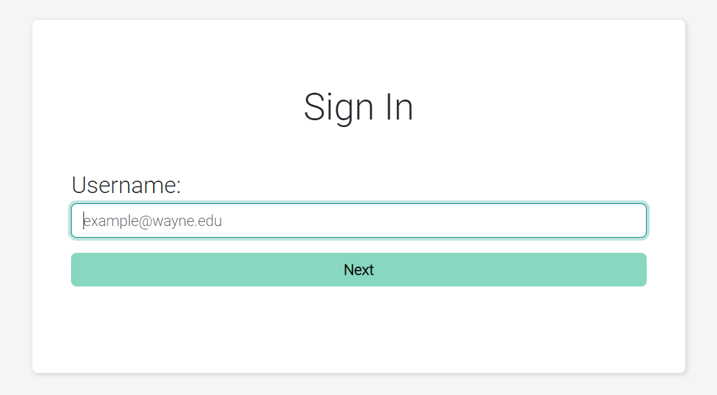Caption: User sign in screen showing username input field.

Alt Text: Image of the user sign-in showing the username input field.

**Step 2**

On this page, enter your email address again in the email input field, and click the receive new password by email button.

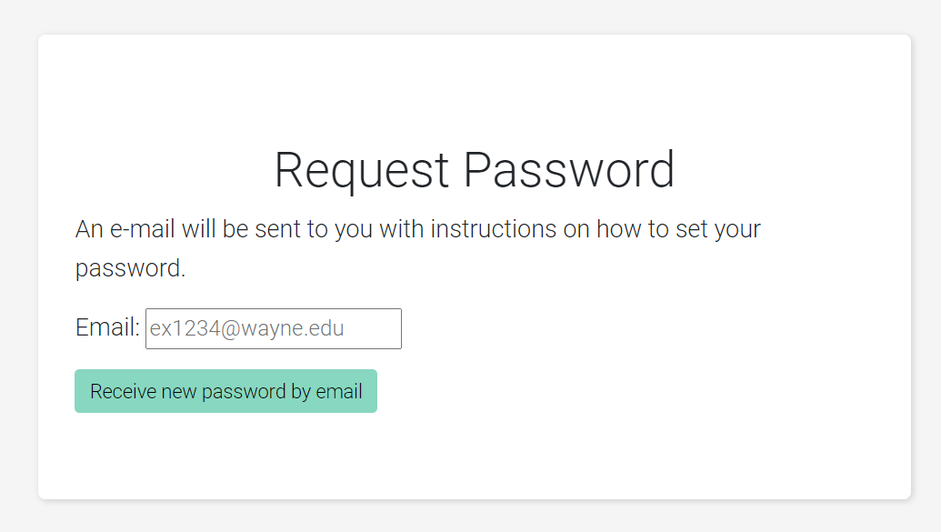

Caption: Request password screen showing email input field

Alt Text: Image of the request password screen showing the email input field.

**Step 3**

Once you receive the password reset email in your inbox, open the email and click on the link provided. This will take you to the page where you can enter your new password.

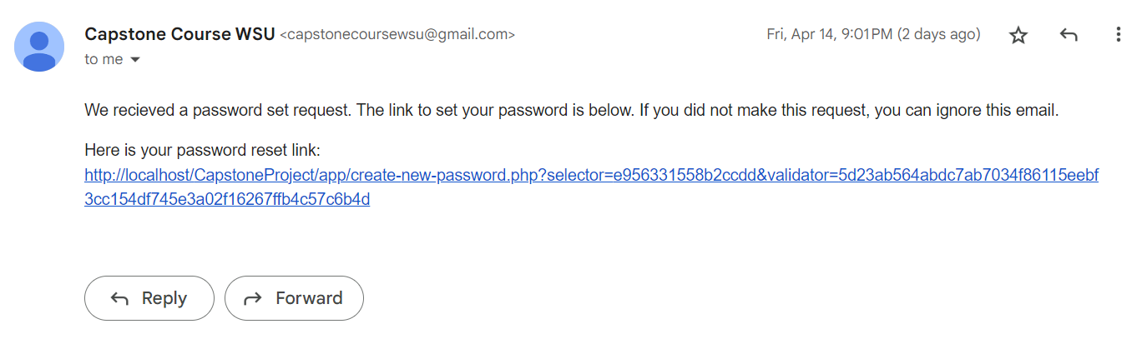

Caption: User inbox screen showing password request email.

Alt Text: Image of the user inbox screen showing the password request email.

**Step 4**

Enter your desired password into the password field and repeat that same password in the “repeat password” field.

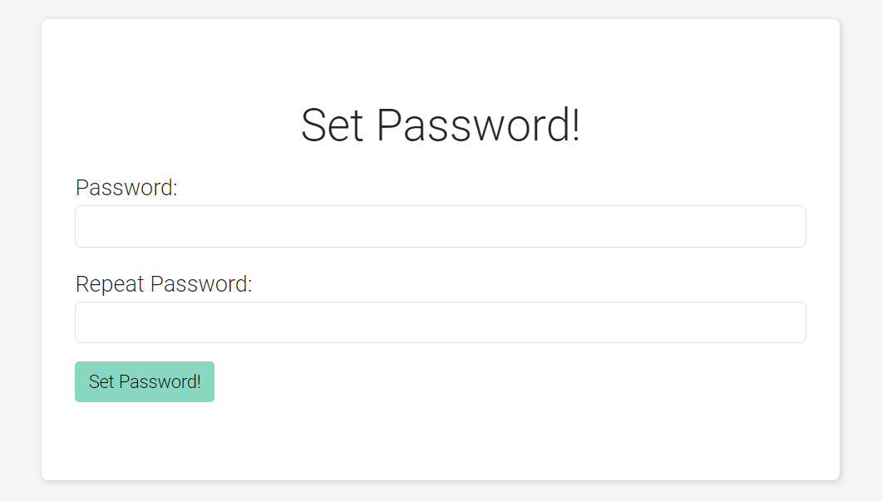Caption: User new password screen showing password input field.

Alt Text: Image of the new password screen showing the new password input field.

**Step 5**

Click the “Set Password!” button to save the new password.

Caption: User new password screen showing password input field.

Alt Text: Image of the new password screen showing the new password input field.

**Expected Result**

The new user should be able to log into the system.

### User Sign In

The user sign in function allows users to access their account withing the system by entering their sign in credentials.

**Step 1**

To begin the sign in process, navigate to the sign in page and enter the username in the input field.

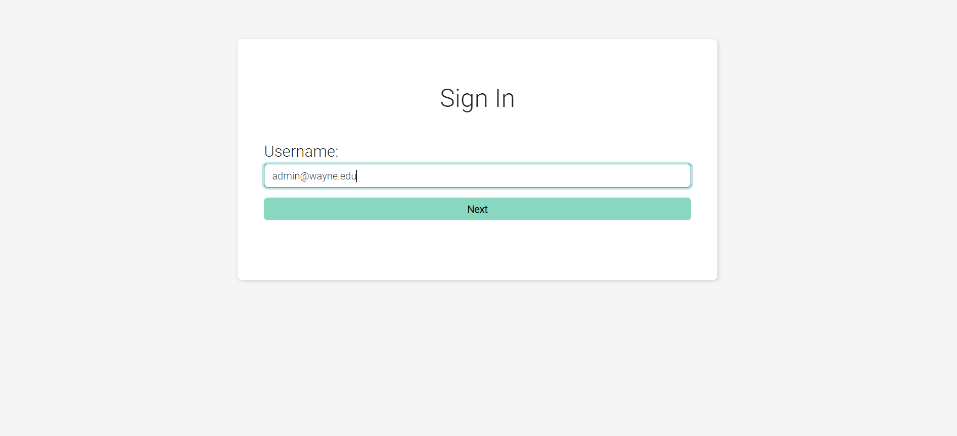

Caption: User sign-in screen showing username input field.

Alt Text: Image of the user sign-in showing the username input field.

**Step 2**

Click the “Next button to proceed to the password entry screen. On this page, enter the password in the password input field and click “Submit” to complete the sign-in process.

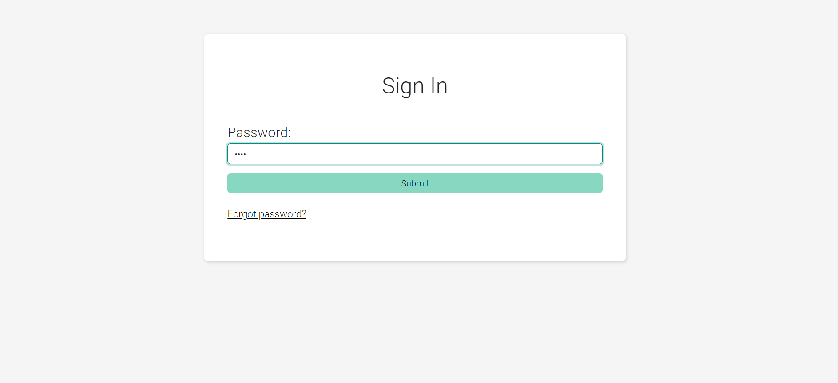

Caption: User sign-in screen showing password input field.

Alt Text: Image of the user sign-in showing the password input field.

**Expected Result**

A new session should be created for the user and successful redirection to the dashboard for an Admin, GTA, or Professor.

### Admin – Create a Semester

To create new semester function allows administrators to add new semesters to the system. This feature enables administrators to enter specific dates for the start and end of each semester.

**Step 1**

Navigate to the “Add Semester/Section” page by clicking the corresponding option in the hamburger tab.

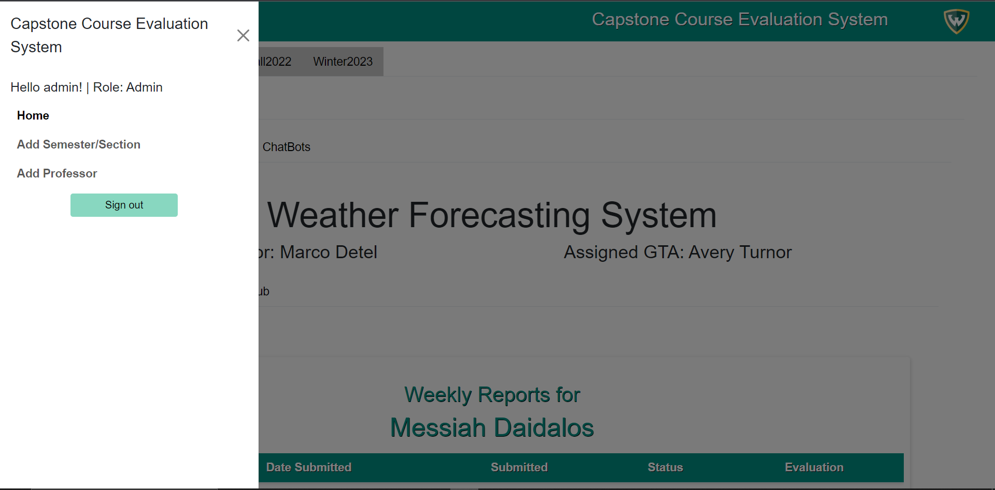

Caption: Home page screen showing hamburger tab with “Add Semester/Section”

Alt Text: Image of the admin home page with the hamburger tab open.

**Step 2**

On the “Add Semester/Section page”, enter the name of the new semester in the “Semester Name” input field.

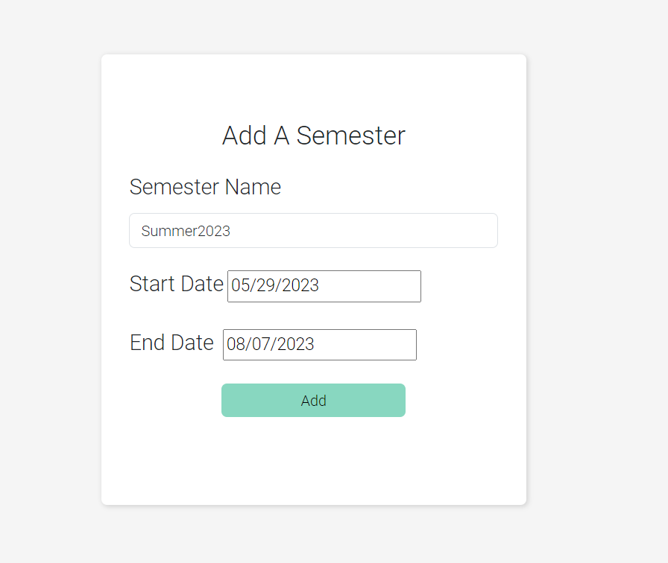

Caption: Create a new semester form showing semester name, start date, end date and add button.

Alt Text: Image of the create a semester form showing input fields for semester name, start date, end date, and add button.

**Step 3**

Enter the start and end dates of the semester in the appropriate input fields by either typing or using the date picker tool. Click the “Add” button at the bottom of the form to create a new semester.

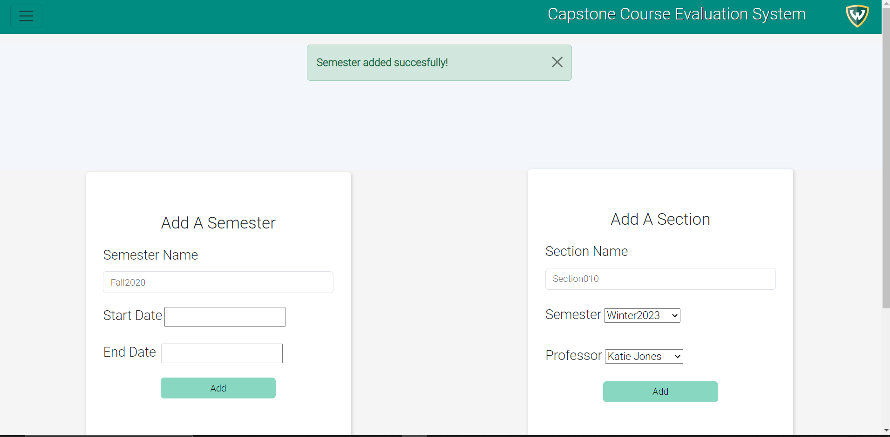

Caption: Create a new semester page showing the semester was added successfully.

Alt Text: Image of the create a semester page showing input fields for semester name, start date, end date, and add button.

**Expected Result**

Once a new semester is successfully added to the database, it can now be assigned sections and will be displayed in the admin dashboard.

**Caveats and Exceptions**

Caveats and exceptions to the new semester creation may include conflicting scheduling requirements.

### Admin – Create a Section

The create a section function allows administrators to add new course sections to the system.

**Step 1**

On the “Add Semester/Section” page, enter the name of the new section in the “Section Name” input field. Add a specific professor to that section using the drop-down menu. Once the semester is assigned, add a specific semester using the drop-down menu.

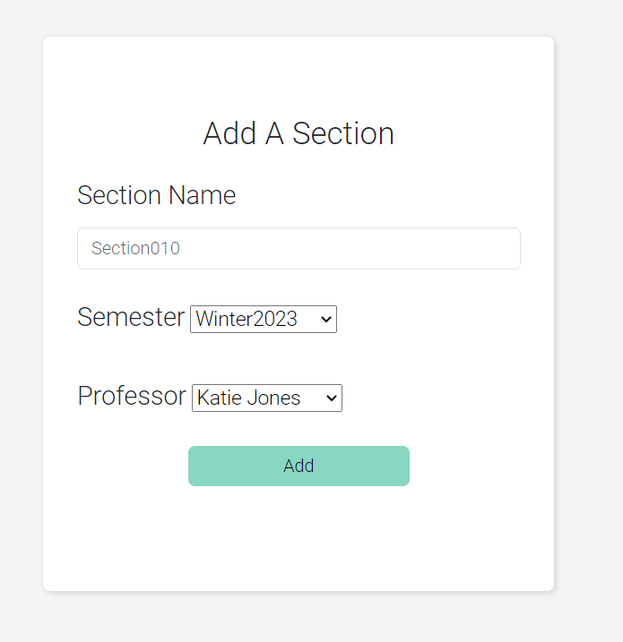

Caption: Create a new section form showing section name, semester drop-down menu, professor drop-down menu and add button.

Alt Text: Image of the create a section form showing input fields for section name, semester drop-down menu, professor drop-down menu and add button.

**Step 2**

Click the “Add” button at the bottom of the form to create a new section.

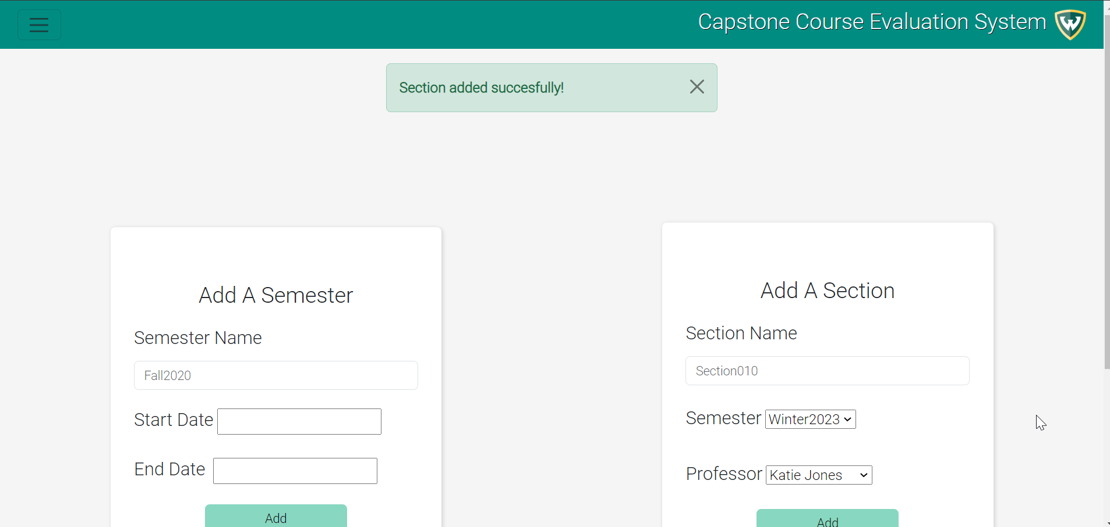

Caption: Create a new section page showing the section was added successfully.

Alt Text: Image of the create a section page showing input fields for section name, semester drop-down menu, professor drop-down menu and add button.

**Expected Result**

A new semester is successfully added, the information will be saved to the database and displayed on the admin dashboard.

**Caveats and Exceptions**

Caveats and exceptions to the section creation process may include conflicting professor or semester requirements.

### Admin – Add a Professor

The add a new professor function allows administrators to add new professors to the system.

**Step 1**

Navigate to the “Add Professors” page by clicking on the corresponding option in the hamburger tab.

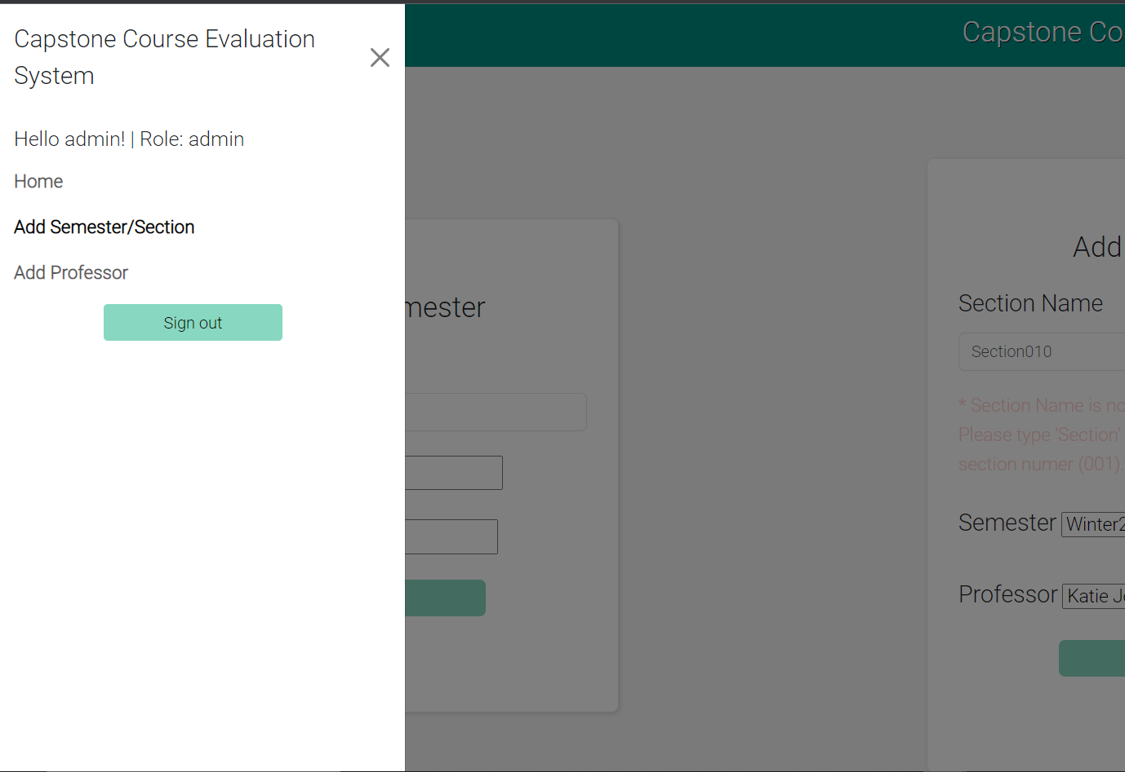

Caption: Add Semester/Section screen showing hamburger tab with “Add Professor”

Alt Text: Image of the Add Semester/Section screen with the hamburger tab open.

**Step 2**

On the “Add Professor” page, fill out all the required fields in the “Add Professor!” form. This includes first name, last name, and email. Once all the input fields have been completed, click the “Add” button at the bottom of the form to create a new professor.

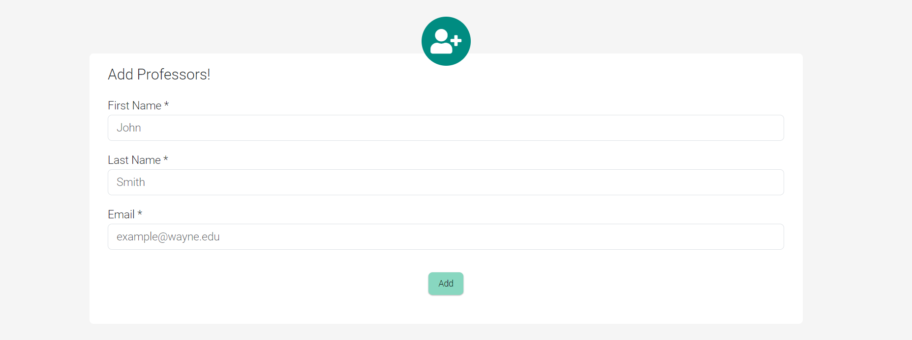

Caption: Add Professor screen showing input box for “Add Professor”.

Alt Text: Image of the Add Professor screen zoomed in on the input box.

**Expected Result**

The output will provide the administrator with a list of professors to manage permissions.

**Caveats and Exceptions**

The professor account verification includes an email verification process.

### Admin – Edit a Professor

The edit professor function allows administrators to modify the information for an existing professor account.

**Step 1**

On the “Add Professor” page, navigate to either the “Activated Professors” or “Deactivated Professors” account tables and select the edit button for a professor.

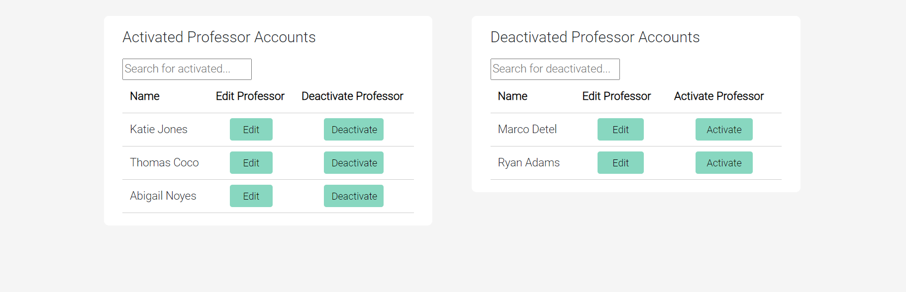

Caption: Add Professor screen showing the “Activated Professors” table and the “Deactivated Professors” table.

Alt Text: Image of the Add Professor screen zoomed in on the professor account tables.

**Step 2**

Edit the first name, last name, or email input box in the edit professor pop up modal. Click “update data” to update a professor’s data.

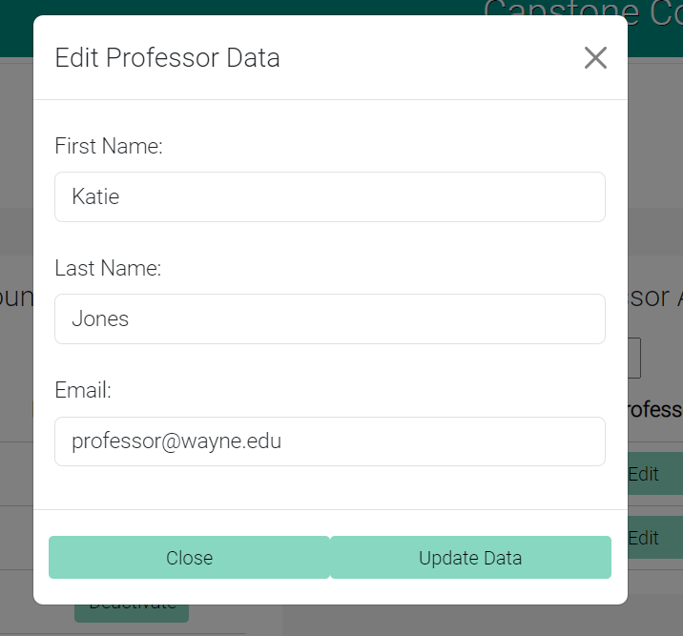

Caption: Add Professor screen showing the “Edit Professor Data” pop up modal.

Alt Text: Image of the Add Professor screen with the” Edit Professor Data” pop up modal open.

**Expected Result**

The database will be updated with the new information. The table will then display the updated data, confirming that the changes have been made successfully.

**Caveats and Exceptions**

The edit professor process will not update professor data and give the user an error message for null or redundant data.

### Admin – Activate or Deactivate a Professor

The activate and deactivate professor functions allow the administrator to remove a professors account access to the system.

**Step 1**

Navigate to the activated and deactivated professor’s tables. Click either “activate” or “deactivate” professor.



Caption: Add Professor screen showing the “Activated Professors” table and the “Deactivated Professors” table.

Alt Text: Image of the Add Professor screen zoomed in on the professor account tables.

**Step 2**

A modal will appear on the screen asking the admin to confirm their choices. Click the “Deactivate” or “Activate” button in the modal.

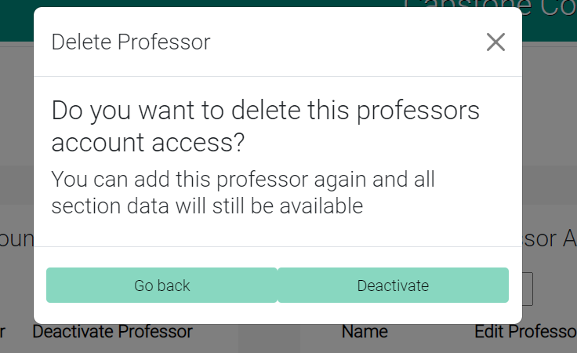

Caption: Add Professor screen showing the “Delete Professor” modal.

Alt Text: Image of the Delete Professor modal.

**Expected Result**

The database will be updated with the new information regarding the professor’s account access. The professor’s data will remain in the database, but they will no longer be able to log into the web application. The deactivation can be confirmed on the web page, in the deactivate professors able.

### Professor – Add Section

The professor can create a section (if the admin has not done so already) for them to begin to create the classroom environment.

**Step 1**

Navigate to the “Add Section” page by clicking on the corresponding option in the hamburger tab.

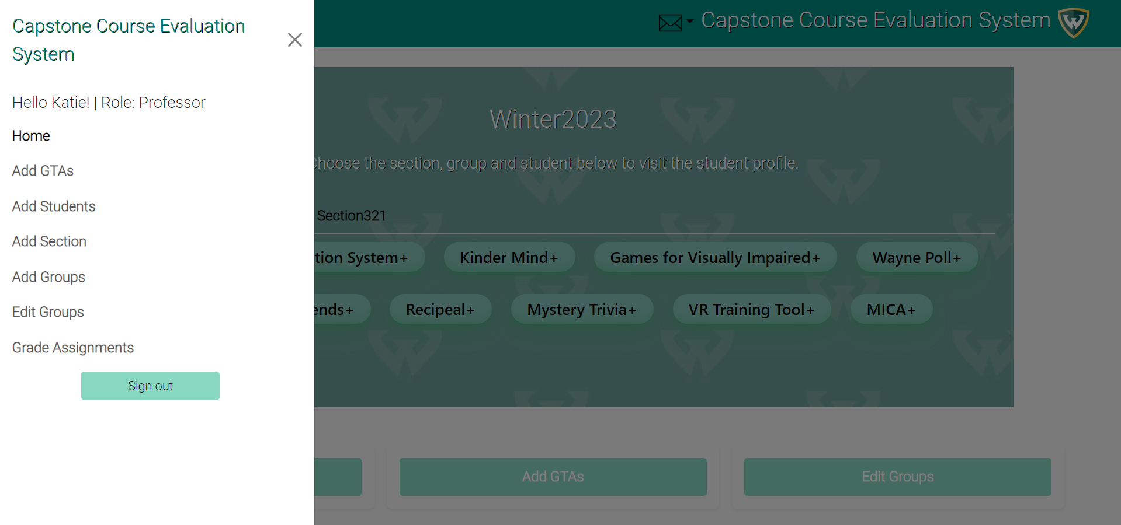

Caption: Home screen showing hamburger tab with “Add Section”

Alt Text: Image of the Home screen with the hamburger tab open.

**Step 2**

On the “Add Section” page, fill out all the required fields in the “Add A Section” form. This includes the name of the section. Once all the input fields have been completed, click the “Add” button at the bottom of the form to create a new section.

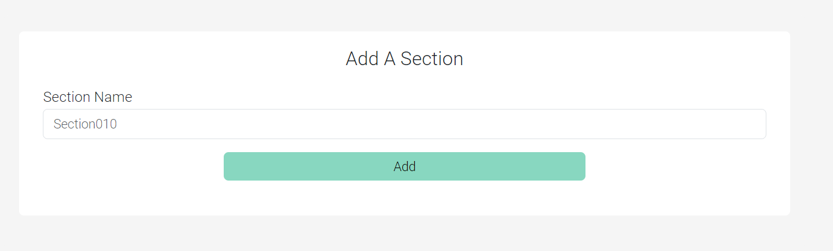

Caption: Add Section screen showing input box for “Add A Section”.

Alt Text: Image of the Add Section screen zoomed in on the input box.

**Expected Result**

A new section is successfully added, the information will be saved to the database and displayed on the professor dashboard.

**Caveats and Exceptions**

If the form is left blank or the professor tries to create a section that he already has, a warning will appear and stop the input from carry out.

### Professor – Add a GTA

The addition of a new GTA function allows professors to add new GTAs to the system.

**Step 1**

Navigate to the “Add GTAs” page by clicking on the corresponding option in the hamburger tab.



Caption: Home screen showing hamburger tab with “Add GTAs”

Alt Text: Image of the Home screen with the hamburger tab open.

**Step 2**

On the “Add GTA” page, fill out all the required fields in the “Add GTA!” form. This includes first name, last name, email, and section. Once all the input fields have been completed, click the “Add” button at the bottom of the form to create a new GTA.

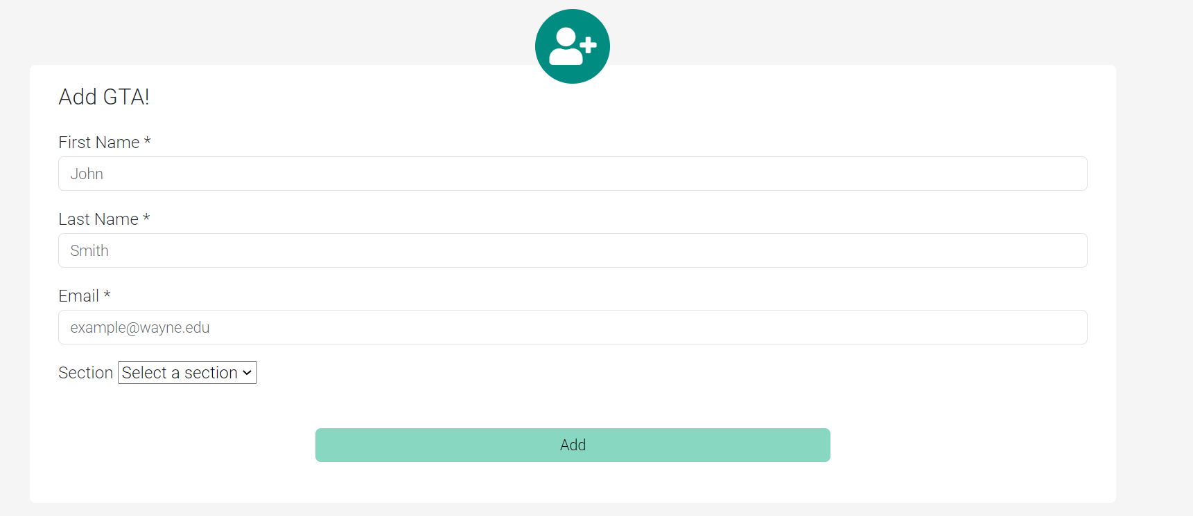

Caption: Add GTA screen showing input box for “Add GTA”.

Alt Text: Image of the Add GTA screen zoomed in on the input box.

**Expected Result**

The output will provide the professor with a list of GTAs to manage permissions.

**Caveats and Exceptions**

The GTA account verification includes an email verification process.

### Professor – Edit a GTA

The edit professor function allows administrators to modify the information for an existing professor account.

**Step 1**

On the “Add GTAs” page, navigate to either the “Activated GTA” or “Deactivated GTA” account tables and select the edit button for a GTA.

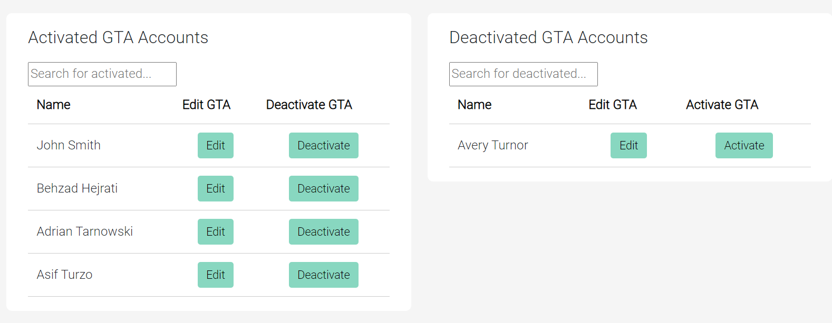

Caption: Add GTA screen showing the “Activated GTA” table and the “Deactivated GTA” table.

Alt Text: Image of the Add GTA screen zoomed in on the GTA account tables.

**Step 2**

Edit the first name, last name, or email input box in the edit GTA pop up modal. Click “update data” to update a GTA’s data.

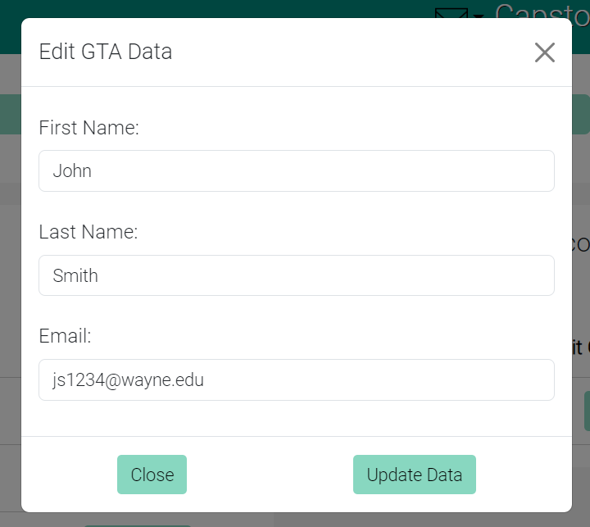

Caption: Add GTA screen showing the “Edit GTA Data” pop up modal.

Alt Text: Image of the Add GTA screen with the “Edit GTA Data” pop up modal open.

**Expected Result**

The database will be updated with the new information. The table will then display the updated data, confirming that the changes have been made successfully.

**Caveats and Exceptions**

The edit GTA process will not update GTA data and give the user an error message for null or redundant data.

### Professor – Activate or Deactivate a GTA

The activate and deactivate GTA functions allow the professors to remove a GTAs account access to the system.

**Step 1**

On the “Add GTAs” page, navigate to the activated and deactivated GTA’s tables. Click either “activate” or “deactivate” GTA.



Caption: Add GTA screen showing the “Activated GTAs” table and the “Deactivated GTAs” table.

Alt Text: Image of the Add GTA screen zoomed in on the professor account tables.

**Step 2**

A modal will appear on the screen asking the professor to confirm their choices. Click the “Deactivate” or “Activate” button in the modal.

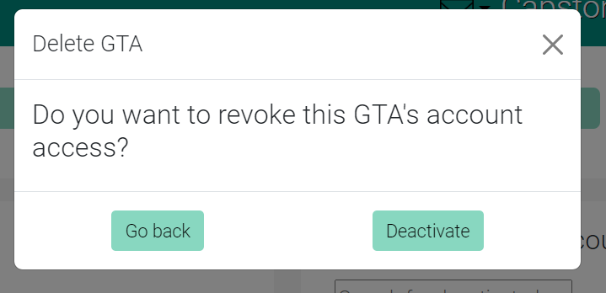

Caption: Add GTA screen showing the “Delete GTA” modal.

Alt Text: Image of the Delete GTA modal.

**Expected Result**

The database will be updated with the new information regarding the GTA’s account access. The GTA’s data will remain in the database, but they will no longer be able to log into the web application. The deactivation can be confirmed on the web page, in the deactivate professors able.

### Professor – Upload Students

The Upload Students function allows the professor to add active students to a section through a upload of a spreadsheet file (.CSV, .ODS, .XLS, .XLSX)

**Step 1**

Navigate to the “Add Students” page by clicking the corresponding option in the hamburger tab.

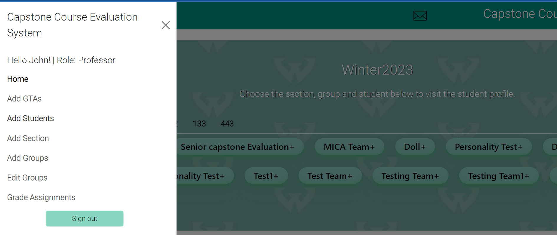

Caption: Home screen showing hamburger tab with “Add Students”

Alt Text: Image of the Home screen with the hamburger tab open.

**Step 2**

On the “Add Students” page, fill out all the required fields in the “Upload Students” form. This includes choosing file and select section. Once all the input fields have been completed, click the “Upload” button at the bottom of the form to add students to a section.

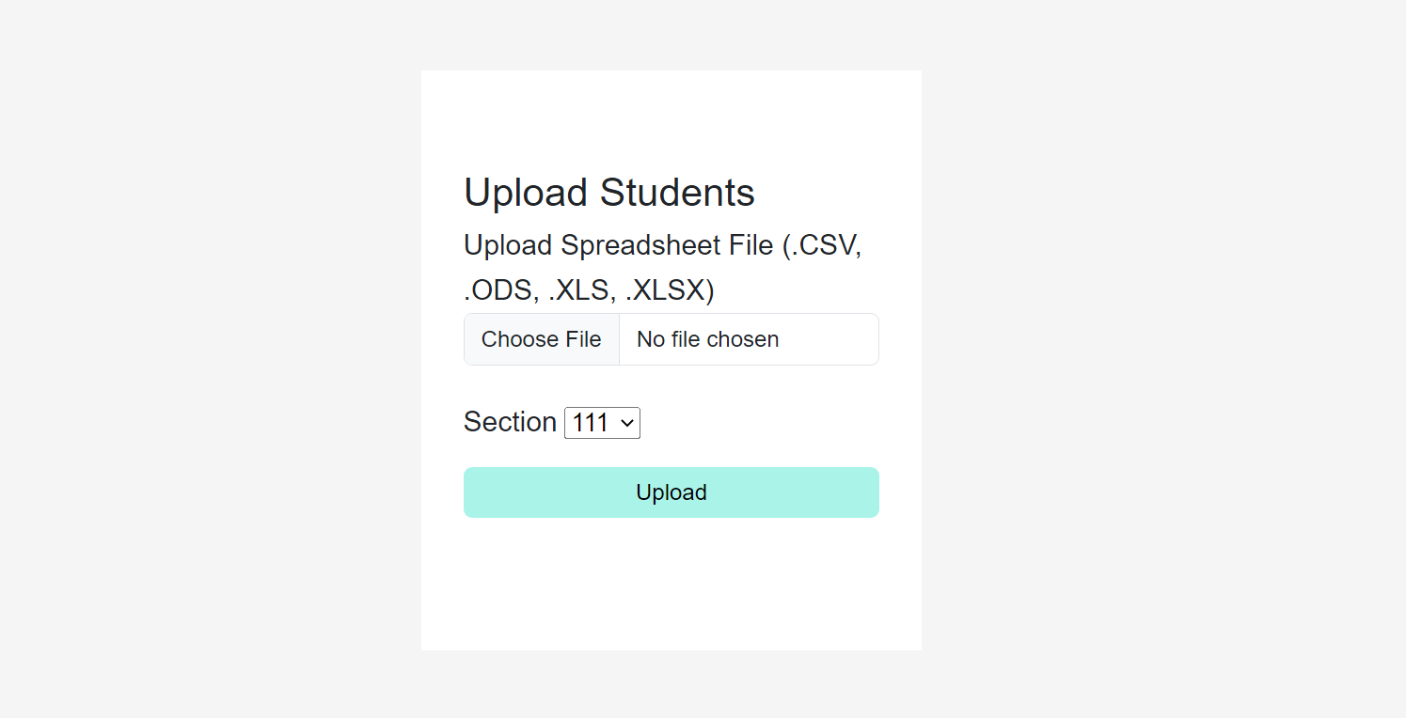

Caption: Upload Students form showing choose file, section dropdown and upload button.

Alt Text: Image of the Upload Students form showing input fields for file upload, section, and upload button.

**Expected Result**

The database will be updated with the new information. The section will now have the students from the spreadsheet assigned to it as active students.

**Caveats and Exceptions**

If an active student is already included in the semester they will not be allowed to be reinserted in the same semester.

### Professor – Create Groups

The Create Groups function allows the professor to insert the groups for each capstone project that have been assigned to a section.

**Step 1**

Navigate to the “Add Groups” page by clicking the corresponding option in the hamburger tab.

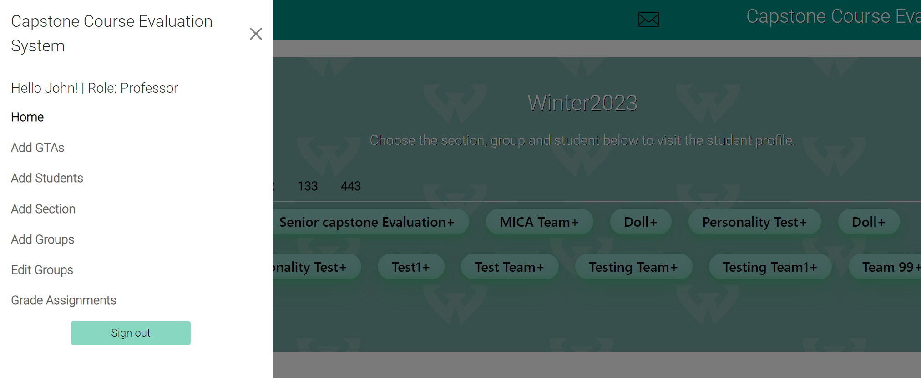

Caption: Home screen showing hamburger tab with “Add Groups”

Alt Text: Image of the Home screen with the hamburger tab open

**Step 2**

On the “Add Groups” page, fill out all the required fields in the “Add a Group” form. This includes just a name field. Once the input field is completed, click the “Save Group(s)” button at the bottom of the form to add the group.

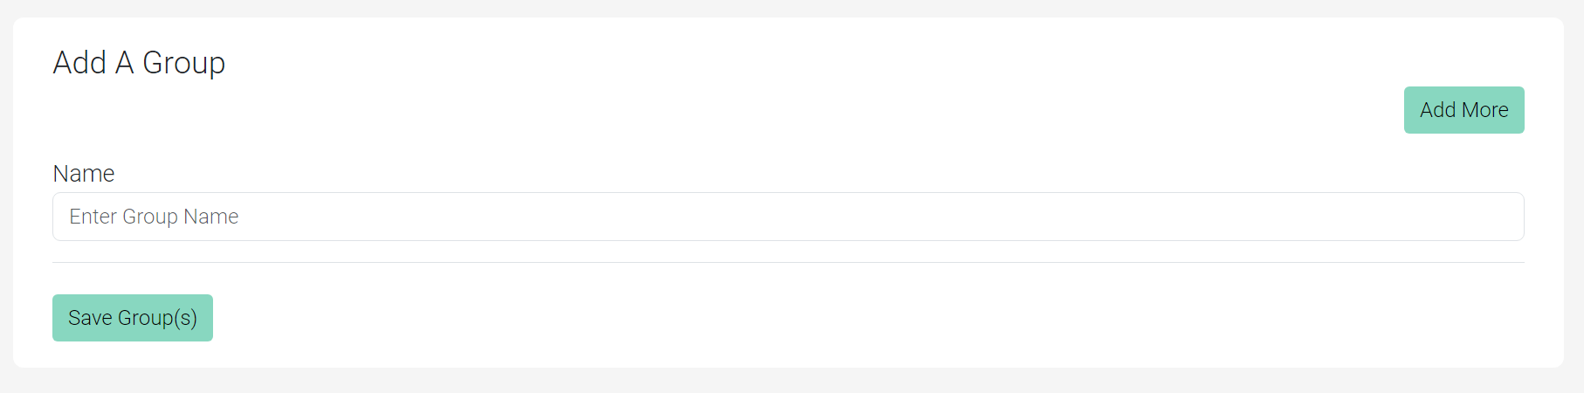

Caption: Add a Group form showing name field and “Save Group(s)” button.

Alt Text: Image of the Add a Group form showing input fields for name and “Save Group(s)” button.

**Expected Result**

The database will be updated with the new information. The group will now be available to the website to assign students and GTAs to.

**Caveats and Exceptions**

Cannot add a group in the section if it already exists.

### Professor – Edit Groups

The Edit Groups function allows the professor to view the active groups of the current semester and edit/remove some information of each group.

**Step 1**

Navigate to the “Edit Groups” page by clicking the corresponding option in the hamburger tab.

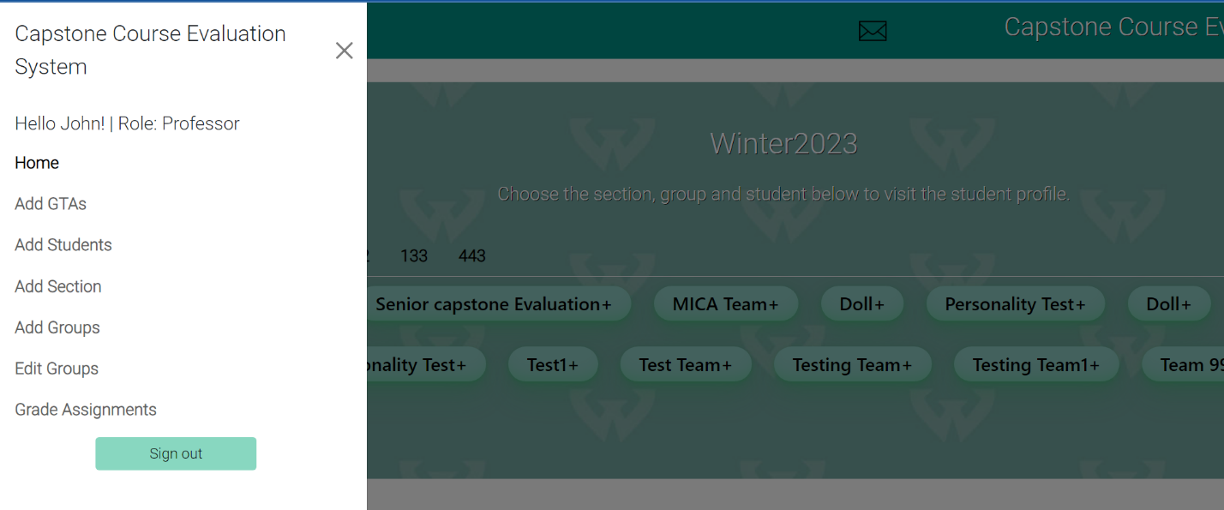Caption: Home screen showing hamburger tab with “Edit Groups”

Alt Text: Image of the Home screen with the hamburger tab open

**Step 2**

On the “Edit Groups” page, navigate to the Groups tables. Click either “edit” or “remove” button.

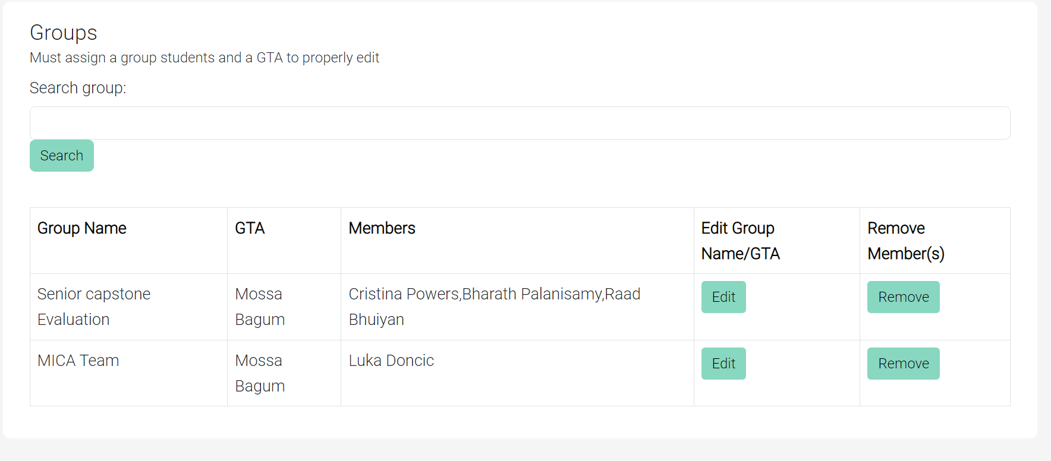

Caption: Edit Groups screen showing the “Groups” table.

Alt Text: Image of the Edit Groups screen zoomed in on the Groups tables.

**Step 3**

A modal will appear on the screen asking the user to change the group name or the GTA assigned to the group if the “Edit” button is pressed or a modal with the checkboxes for each student in the group. Click the “Save” or “Remove” button in the modal.   
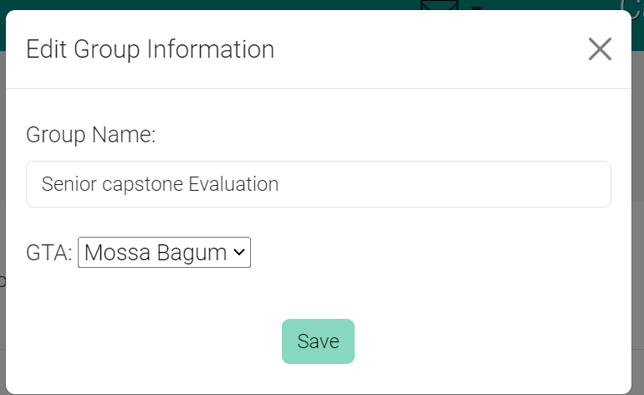

Caption: Edit Groups screen showing the “Edit Group Information” modal.

Alt Text: Image of the Edit modal.

**Expected Result**

The database will be updated with the new information regarding the group’s information. The table will be updated with the new information inputted by the user.

### Professor – Flag a student.

The flag a student feature allows professors to flag student’s weekly reports which are graded by the GTA’s.

**Step 1**

On the professor dashboard, the groups will be displayed under there section, click on one of the groups, for this example we will be clicking the “Capstone Course Evaluation System.”

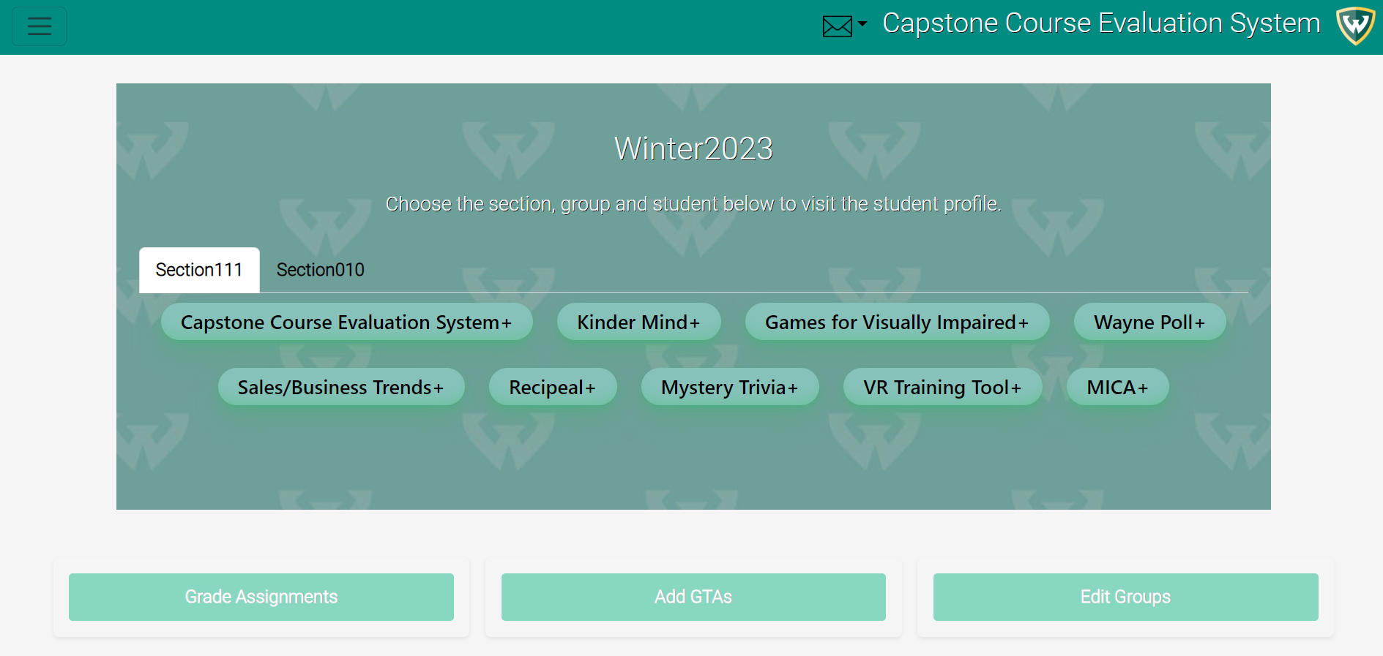

Caption: Professor Dashboard screen showing the “groups” modal.

Alt Text: Image of the professor dashboard modal.

**Step 2**

After clicking on a group button, the students in the group will appear, click on the student you would like to view. For this example, we will be clicking the student with the name “Cristina Powers.” 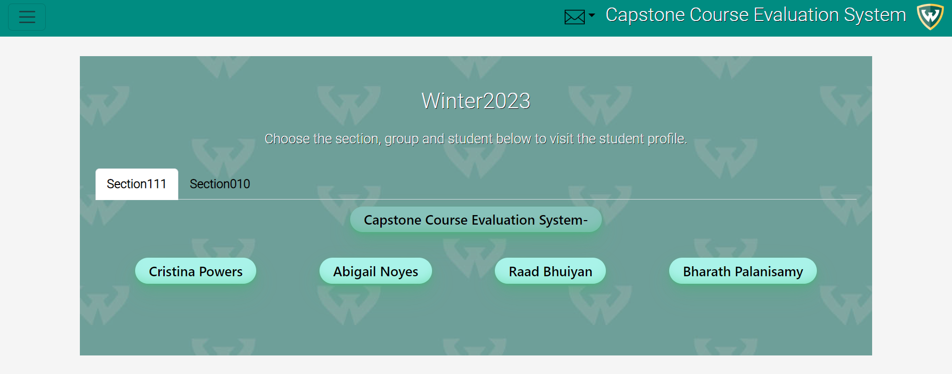

Caption: Professor Dashboard screen after clicking on the group showing the “students” in the modal.

Alt Text: Image of the Professor dashboard after clicking the group.

**Step 3**

On the “Student Page”, click the “flag” icon which is located on the right. 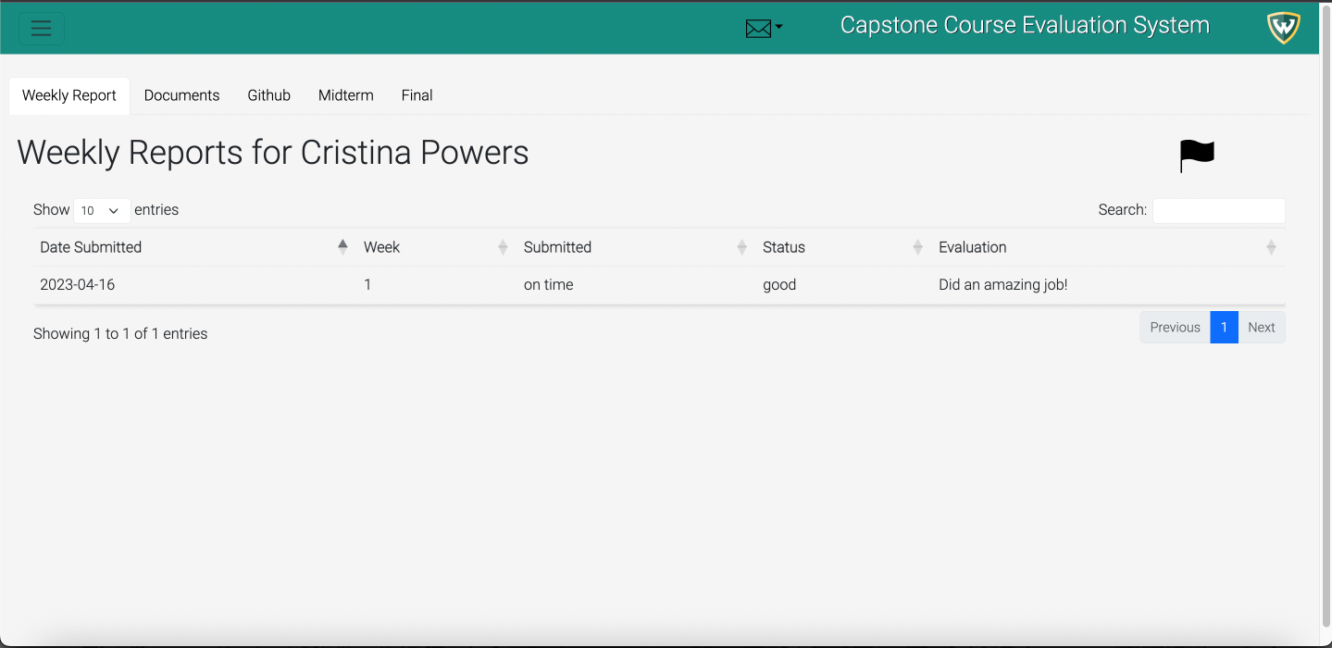

Caption: Professor screen after clicking on the student.

Alt Text: Image after clicking the student in the professor dashboard.

**Step 4**

A modal will appear on the screen asking the user to enter a message to the GTA. Once done, the professor will have the option to “close” the pop-up modal or “Send message” to the GTA notifying them about a weekly report.

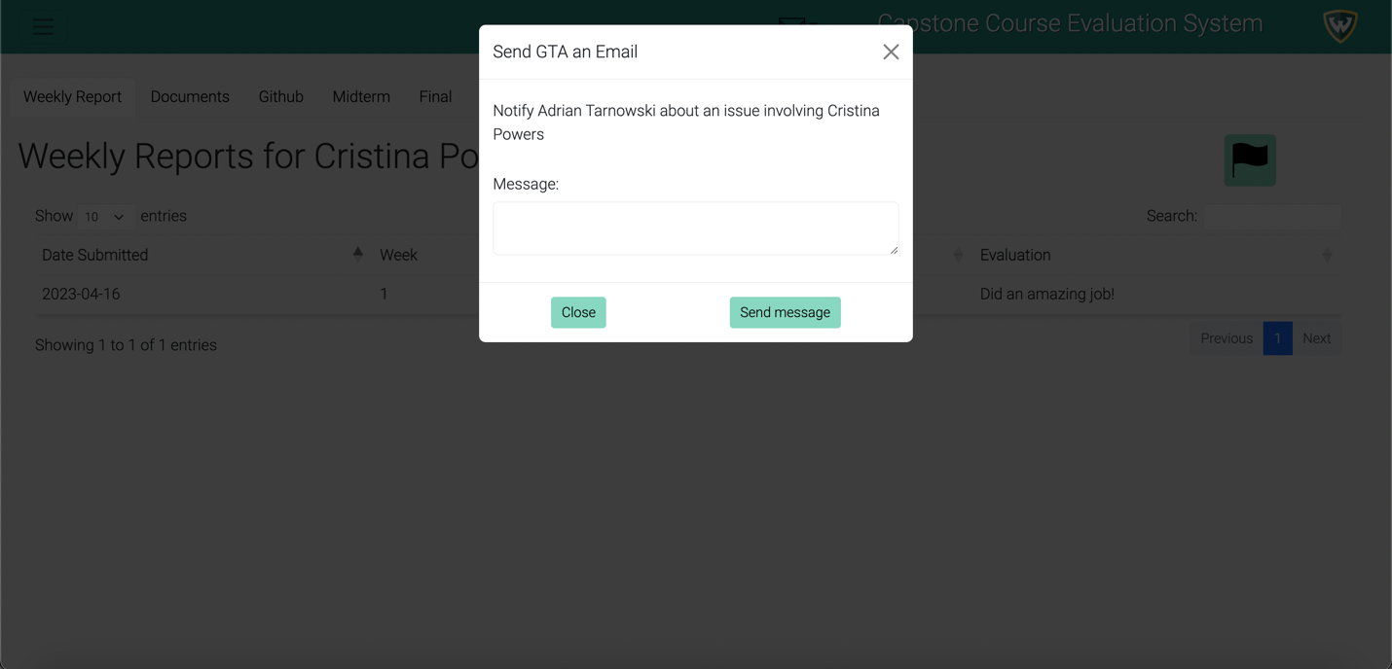

Caption: Professor screen after clicking on the flag icon.

Alt Text: Image after clicking the Flag icon.

**Expected Result**

The GTA will have a notification in the message icon of the GTA dashboard page. The database will have also updated which allows the professor to manage the information much easier.

### Professor – View Flagged Messages

This feature allows the professor to view the flagged message that they sent to the GTA.

**Step 1**

This feature is on the navigation bar on every single page but for this example we will be showing access to it from the professor dashboard. On the professor dashboard, click on the “Message icon” which is indicated by an envelope on the navigation bar next to the applications name.



Caption: Professor Dashboard screen showing the “Message icon” modal.

Alt Text: Image of the professor dashboard modal.

**Step 2**

This screen of the application shows the professor the messages which were flagged and sent to the GTA.

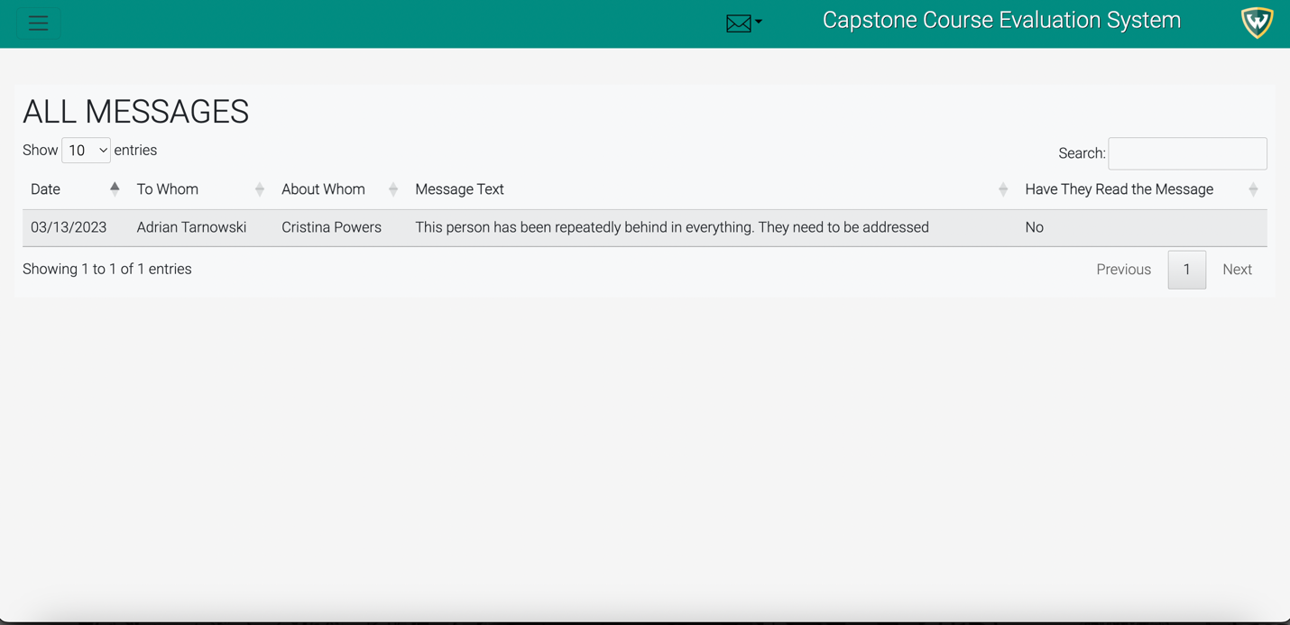

Caption: Professor screen showing the flagged messages screen.

Alt Text: Image of the flagged message’s view for the professor.

**Expected Result**

The professor should be able to view the flagged messages which have been sent to the GTA’s.

### Professor – Grade Assignments

The Grade Assignments function allows the professor to input his own grades and evaluation for each assignment in the semester for each group and student.

**Step 1**

Navigate to the “Grade Assignment” page by clicking the corresponding option in the hamburger tab.

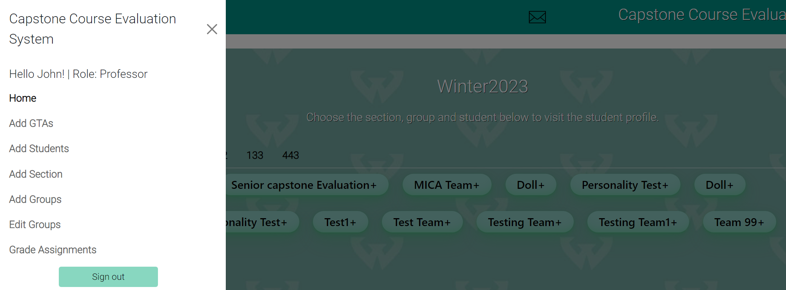

Caption: Home screen showing hamburger tab with “Grade Assignments”

Alt Text: Image of the Home screen with the hamburger tab open

**Step 2**

On the “Grade Assignments” page, select which section, group and documentation/presentation to grade for.

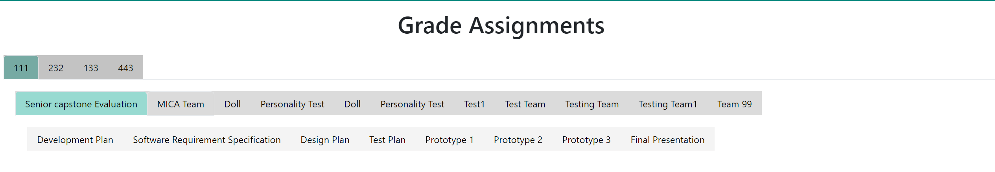

Caption: Grade Assignment screen showing the tab selection of a section, group, and document/presentation assignment.

Alt Text: Image of the Grade Assignment screen zoomed in on the tabs.

**Step 3**  
On the “Grade Assignments” page, fill out all the required fields in the presentation/documentation grade form. This includes assigning a letter grade and notes for specific criteria depending on if it’s a document or presentation as a group as well as for each individual member. Once all the input fields have been completed, click the “Submit Grade” button at the top of the form to save the grades.



Caption: Grading form for the development plan and the submit grade button.

Alt Text: Image of the development plan grade form zoomed out showing all the input fields.

**Expected Result**

The grades will be successfully added to the database and the new grades will be updated on to the same page.

### Professor – View Students Grades

This allows the professor to view the student’s grades which are graded by the professor and GTA. But this feature allows the professor to view student’s grades.

**Step 1**

On the professor dashboard, the groups will be displayed under there section, click on one of the groups, for this example we will be clicking the “Capstone Course Evaluation System.”



Caption: Professor Dashboard screen showing the “groups” modal.

Alt Text: Image of the professor dashboard modal.

**Step 2**

After clicking on a group button, the students in the group will appear, click on the student you would like to view. For this example, we will be clicking the student with the name “Cristina Powers.”



Caption: Professor Dashboard screen after clicking on the group showing the “students” in the modal.

Alt Text: Image of the Professor dashboard after clicking the group.

**Step 3**

On the “Student Page”, click the “Documents” tab which is located next to the “Weekly Report” tab. 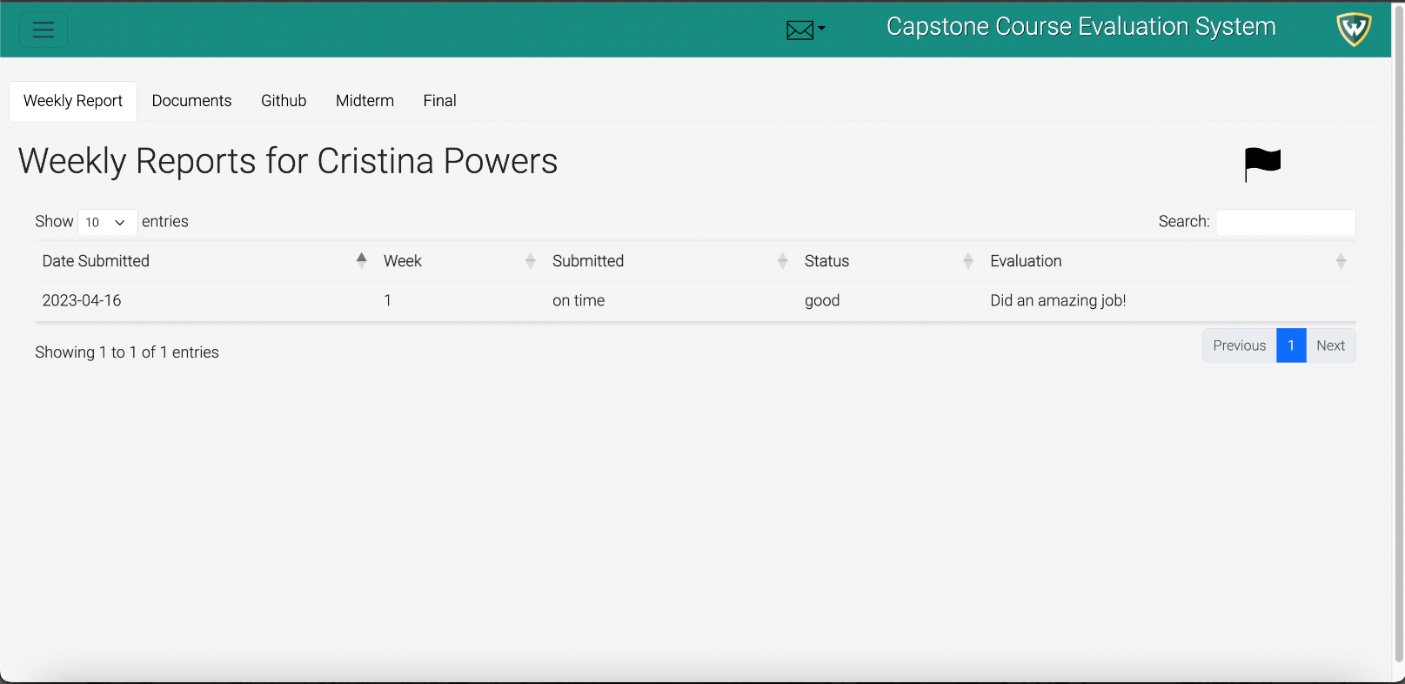

Caption: Professor screen after clicking on the student.

Alt Text: Image after clicking the student in the professor dashboard.

**Step 4**

Click on the “Documents” tab, to view the grades for each individual student.

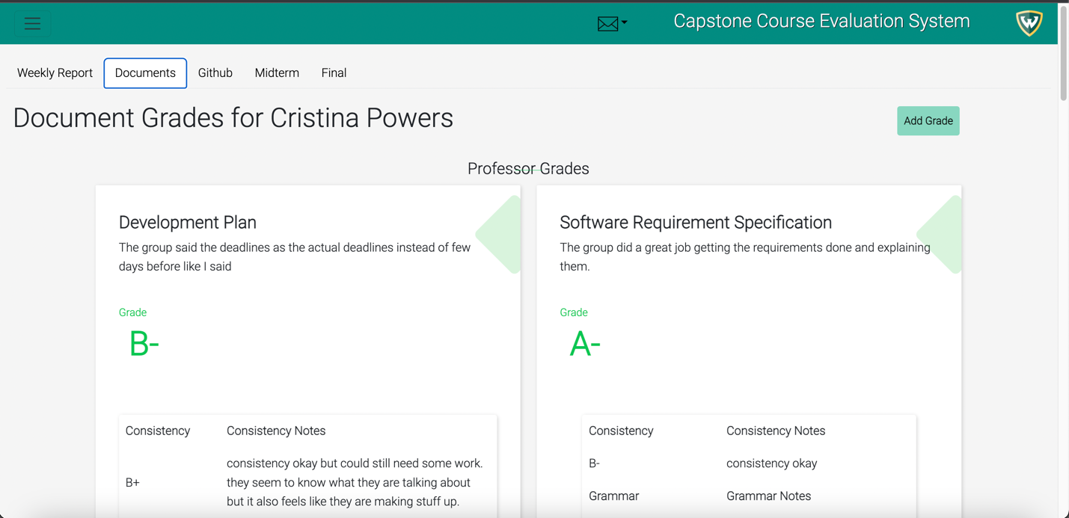

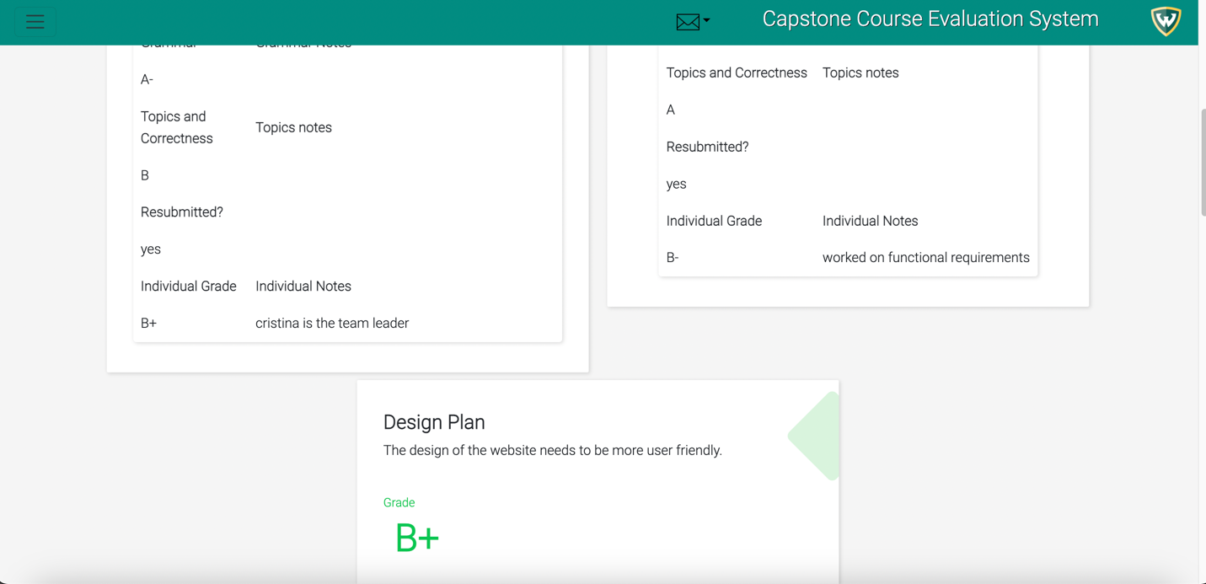

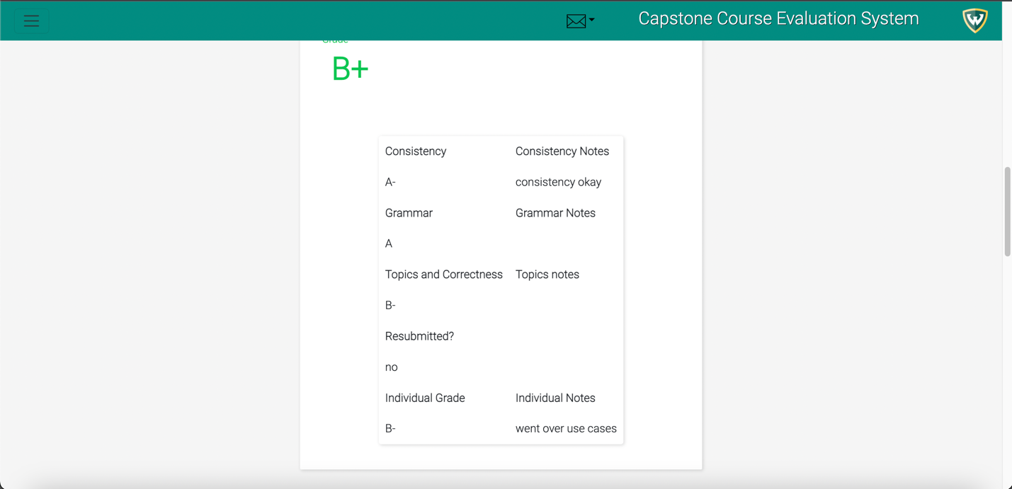

Caption: Professor screen after clicking on the “Document” tab.

Alt Text: Image after clicking the “Document” tab.

**Expected Result**

The professor will be able to view the grades of each document, the students GitHub activity, Midterm, and final grade by clicking on each of the tabs.

### GTA – Choose Groups

The Grade Assignments function allows the professor to input his own grades and evaluation for each assignment in the semester for each group and student.

**Step 1**

Navigate to the “Choose Groups” page by clicking the corresponding option in the hamburger tab.

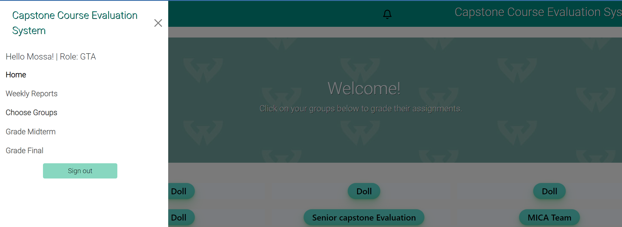

Caption: Home screen showing hamburger tab with “Choose Groups”

Alt Text: Image of the Home screen with the hamburger tab open

**Step 2**  
On the “Choose Groups” page, select which groups using the checkbox to assign to the logged in GTA through the “Choose your Groups” form. Then click the “Assign” button.

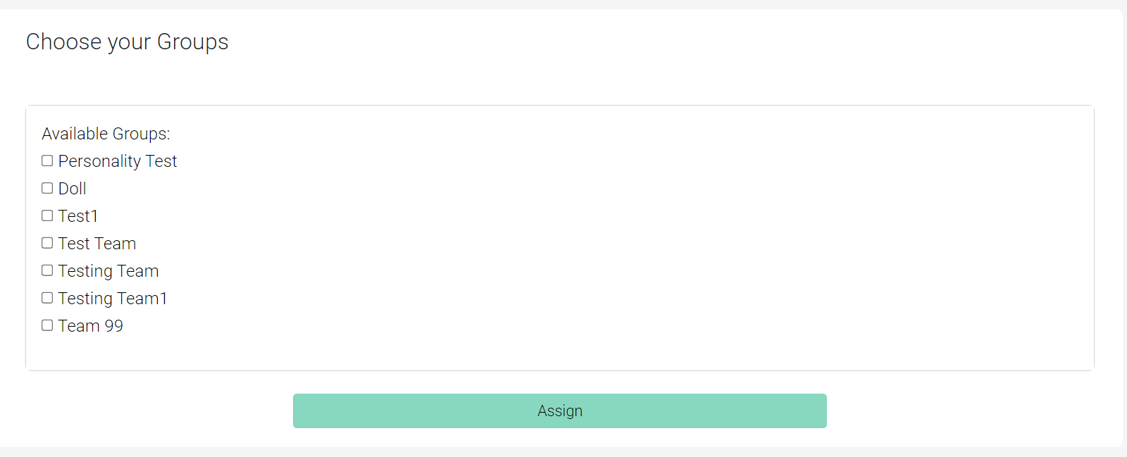  
Caption: “Choose your Group” form that lists all the available groups that the GTA can assign themselves.

Alt Text: Image of the “Choose your Group” form on the “Choose Groups” page zoomed in.

**Expected Result**

The selected groups will be assigned to the GTA and can be available to grade and evaluate in the grading pages.

### GTA – Grade Weekly Reports

This Grade Weekly Reports feature allows the GTA to input their information for the weekly report of the students. They will also be able to grade individual students and asses the entire group to let the professor know.

**Step 1**

Navigate to the “Weekly Reports” by clicking on the corresponding information in the hamburger tab.

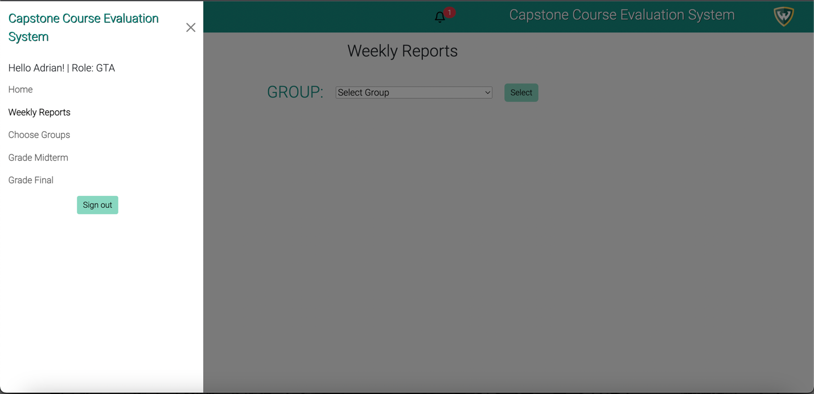

Ca Caption: Home screen showing hamburger tab with “Weekly Report”

Alt Text: Image of the Home screen with the hamburger tab open.

**Step 2**

The GTA will be taken to the weekly report page. This page allows the GTA to select which group they want to assess.

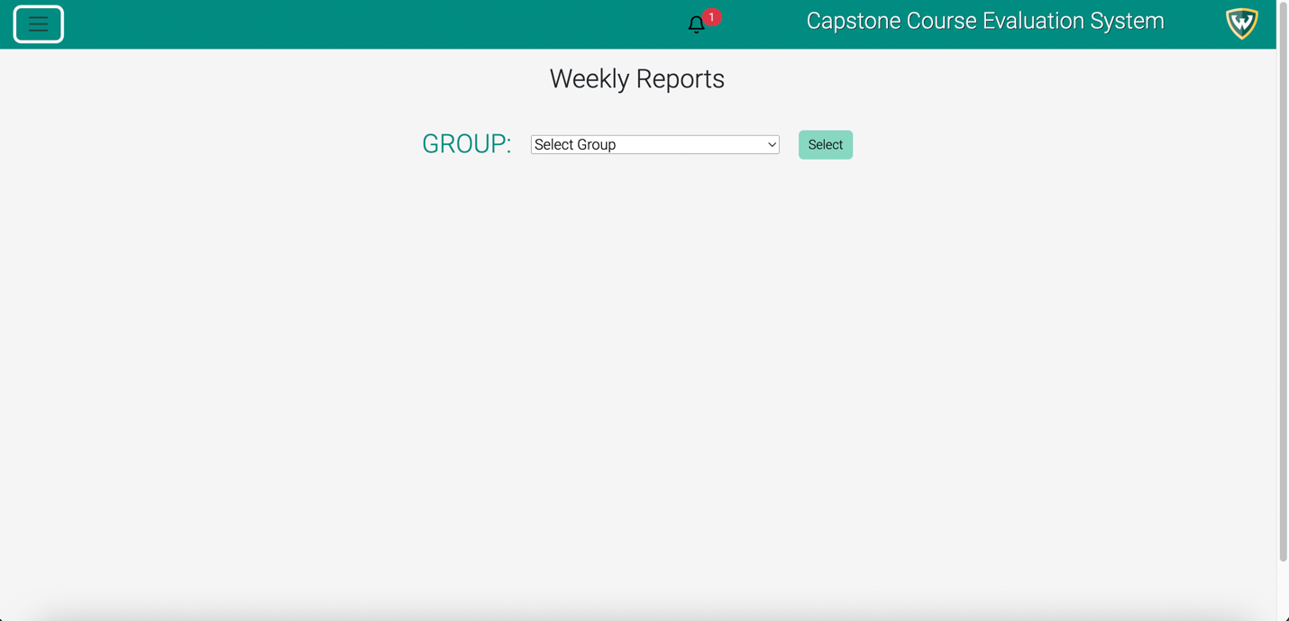

Caption: The GTA will be taken to the page to where they can select which group they want to grade.

Alt Text: Image of the selection of groups to assess for the weekly report.

**Step 3**

The GTA will be allowed to select which group with the drop-down menu. The GTA selects “Capstone Course Evaluation System”.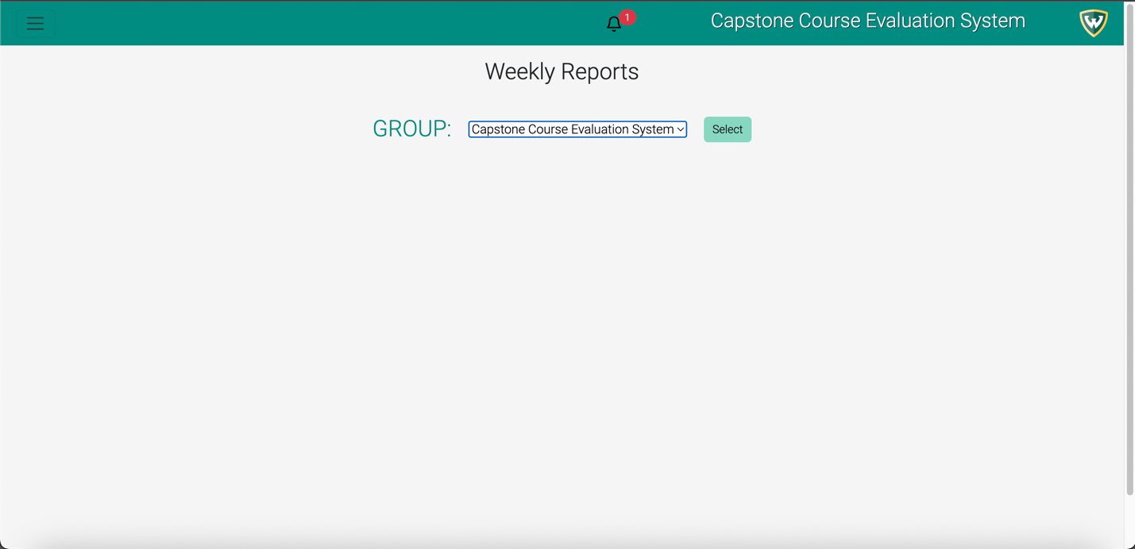

Caption: Selection of the group that GTA wants to select.

Alt Text: Image of the selection of group to grade for the Weekly Report.

**Step 4**

After the GTA clicks “select”, the GTA will be taken to the weekly report page. Where the GTA will be assess the group and student weekly report. 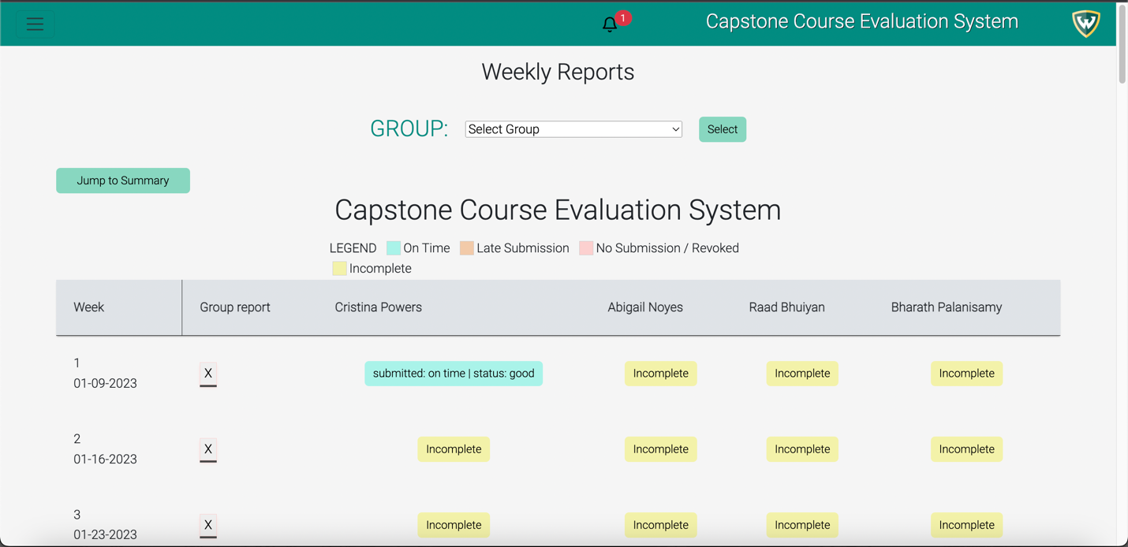

Caption: The GTA will see this page after clicking “Select”.

Alt Text: Image of the Weekly reports page to grade after clicking “Select”.

**Step 5**

GTA clicks on the “X” icon to grade the groups weekly report for that week. The GTA enters an “Evaluation” in the modal for the group. Once the GTA is done, the GTA has the option to “Close” the modal or “Update Data” which updates the data for the group weekly report. 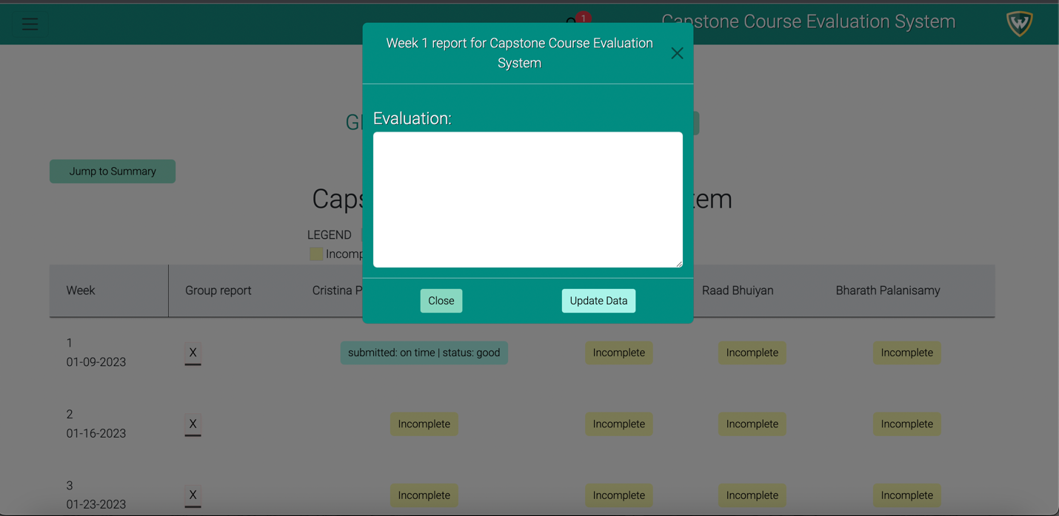

Caption: After the “X” icon is clicked, the green modal appears. The GTA has the option to “Close” and “Update Data” in the modal.

Alt Text: Image of the grade weekly report of the group modal.

**Step 6**

Navigate to the “Incomplete” icon to grade Abbey. GTA has the option to “Close” or “Update Data” the modal. In this case, the GTA is grading students in the “Capstone Course Evaluation System”.

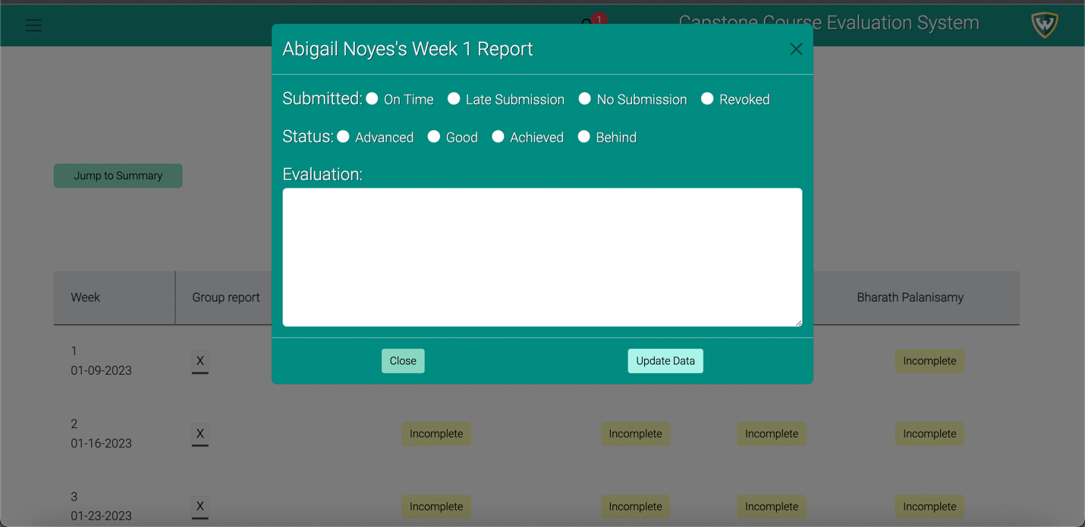

Caption: Once the GTA clicks on the “Incomplete” icon, the GTA will be taken to this modal which will allow the GTA to evaluate each student work for that week.

Alt Text: Image of the Individual grade modal for the weekly report.

**Expected result**

The weekly report dashboard will be updated with the updated information which the GTA has graded. The professor will also be able to view the weekly reports graded by the GTA’s as explained 3.18.

### GTA – Grade Assignments

The Grade Assignments function allows the GTA to input their own grades and evaluation for the work and contribution for each of their assigned groups as well as for the midterm and final grades.

**Step 1**

On the “Grade Midterm” or “Grade Final” page, select which group and member you want to grade.

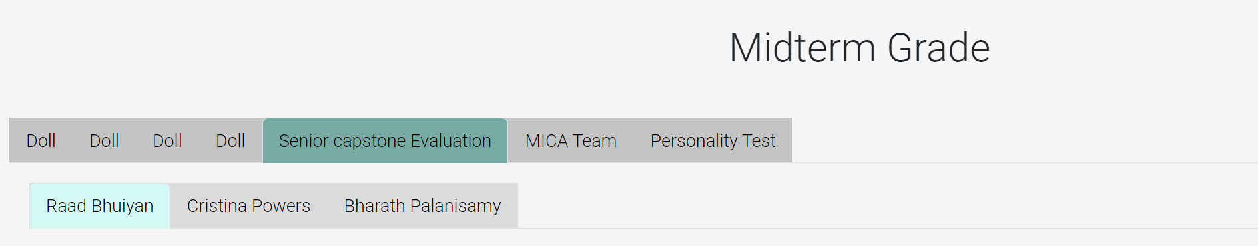

Caption: Grade Midterm screen showing the tab selection of a group, and member.

Alt Text: Image of the Grade Midterm screen zoomed in on the tabs.

**Step 2**  
On the “Grade Midterm” or “Grade Final” page, fill out all the required fields in the grade form. This includes assigning a letter grade and notes for each individual member. Once all the input fields have been completed, click the “Submit Grade” button at the top of the form to save the grades.

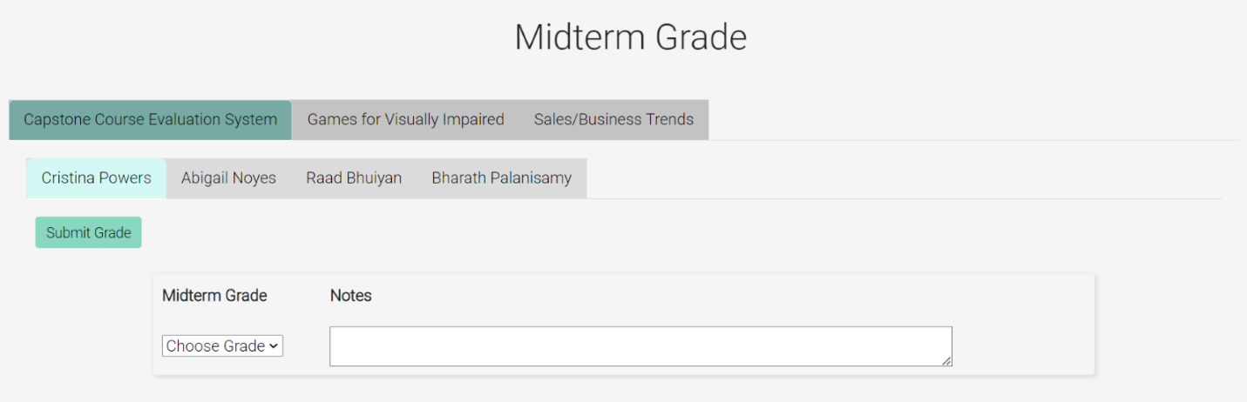

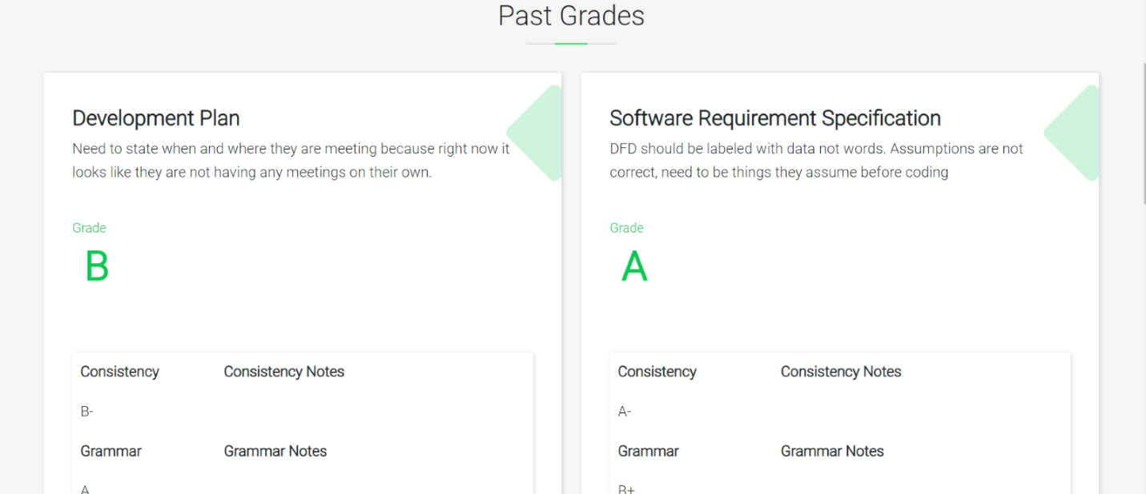

Caption: Grading form for the midterm, development plan, and SRS for a group member and the submit grade button.

Alt Text: Image of the midterm grade form on the “Grade Midterm” page zoomed in.

**Expected Result**

The grades will be successfully added to the database and the new grades will be updated on to the same page to be viewed.

### GTA – View Messages from Professor

The View Messages from Professor function allows the GTA to view the message the professor has sent to the GTA regarding one of his assigned students.

**Step 1**

On the nav bar on top of a page navigate to the bell icon and click “View Messages”.

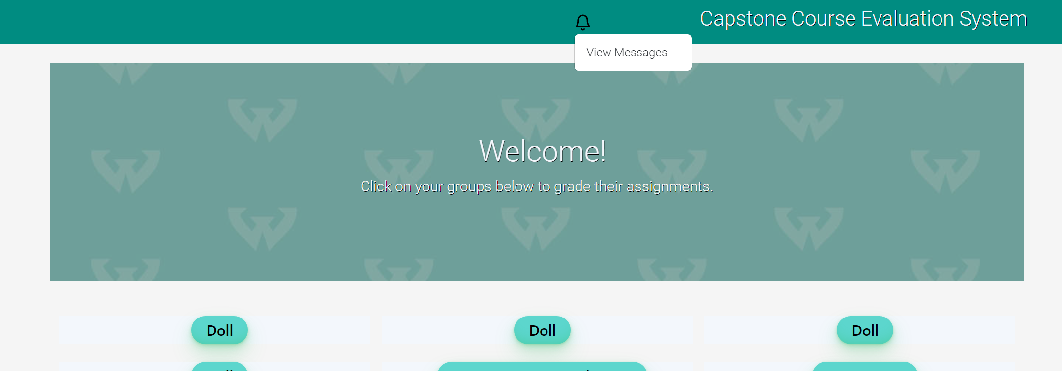

Caption: The bell that leads to the notification page on the GTA home page

Alt Text: Image of a bell symbol on the navbar of the GTA home page

**Step 2**

Once a message from the professor is sent click the “Reveal message button” to view the message sent by the professor

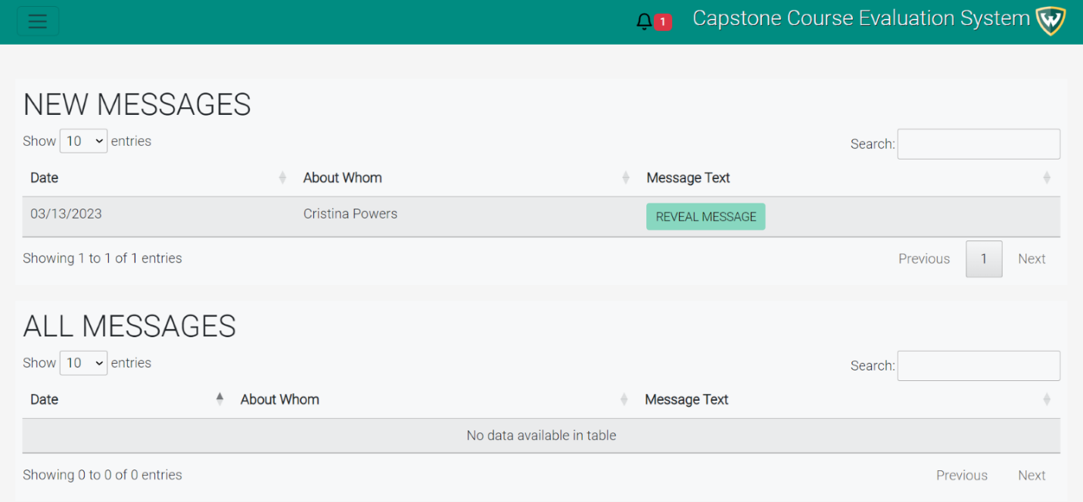

Caption: The GTA notification page that shows all the old and new messages sent from the professor.

Alt Text: Image of the GTA notification page that’s shows a new unopened message sent from the professor.

**Expected Result**

Once the button is clicked the next time the GTA visits the page that message will be moved to the “All Messages” table where they can still see the message.

## Troubleshooting & Support

### Error Messages

If a user attempts to enter incorrect information into an input field, an error message will appear to alert them to the mistake and prompt them to provide the correct information. The error message will be displayed prominently in red, near the location of the error, to ensure that the user is promptly informed of the mistake. For instance, if an admin attempts to create a semester using the name "spring23", the error message will appear beneath the submit button and read as follows: "*Semester Name is not in the correct format. Please use the following format: Semester (Fall/Winter/Summer) followed by the year (2023). Capitalization and spacing matter.”

### Support

If there are any problems or questions about the Capstone Course Evaluation System, please reach out to the computer science department of Wayne State University with any questions, comments, or concerns.

Appendix A: Record of Changes

It is recommended to track and document all changes and revisions to the User Manual. This can be accomplished by utilizing a record of changes table, which should be routinely maintained to ensure the user manual remains current and accurate.

Table 1 - Record of Changes

| Version Number | Date | Author/Owner | Description of Change |
| --- | --- | --- | --- |
| v.1.0 | 4/11/2023 | Cristina Powers | The table of contents located on ii and iii has been added. |
| v.1.0 | 04/11/2023 | Cristina Powers | The introduction paragraph located on page 1 has been added. |
| v.1.0 | 04/13/2023 | Abigail Noyes | The introduction paragraph located on page 1 has been modified to include the version number, name, and release date. |
| v.1.0 | 4/13/2023 | Abigail Noyes | Sections 1.1, 1.2, 1.3 and 1.4 have been added to the introduction section spanning pages 1 through 3. |
| v.1.0 | 4/13/2023 | Cristina Powers | Sections 2, 2.1, 2.2, 2.3, 2.3, 2.4, 2.5, 2.6 have been added to the getting started section spanning pages 4 and 5. |
| v.1.0 | 4/14/2023 | Abigail Noyes | Sections 3, 3.1, 3.2, 3.3, 3.4, 3.5, 3.6, and 3.7 have been added to pages 6 through 18. |
| v.1.0 | 4/16/2023 | Cristina Powers | Sections 3.8-3.11 have been added |
| v.1.0 | 4/16/2023 | Raad Bhuiyan | Sections 3.12-3.14, 3.17, 3.19, 3.21, 3.22 have been added. |
| v.1.0 | 4/16/2023 | Bharath Palanisamy | Sections 3.15, 3.16, 3.18, 3.20, have been added. |

Appendix B: Glossary

Table 2 - Glossary

| Term | Acronym | Definition |
| --- | --- | --- |
| Graduate Teaching Assistant | GTA | A graduate teaching assistant (GTA) is a graduate student who is employed by a university or college to assist in teaching undergraduate courses or laboratory sections. |
| Capstone Course Evaluation System | CCES | The capstone course evaluation system is the name of the system. |

Appendix C: Referenced Documents

Table 3 - Referenced Documents

| Document Name | Document Location and/or URL | Issuance Date |
| --- | --- | --- |
| Development Plan | Git Repository | 01/25/2023 |
| Software Requirements Specification | Git Repository | 02/13/2023 |
| Design Specification | Git Repository | 02/27/2023 |
| Test Plan | Git Repository | 3/25/2023 |

Appendix D: Approvals

The undersigned acknowledge that they have reviewed the User Manual and agree with the information presented within this document. Changes to this User Manual will be coordinated with, and approved by, the undersigned, or their designated representatives.

Table 4 - Approvals

| Document Approved By | Date Approved |
| --- | --- |
| Name: Cristina Powers, Project Manager – Wayne State | 4/18/2023 |
| Name: Hamid Asadi, Client – Wayne State University |  |